

Problem List

User Manual

Version 2.0

August 2014

Product Development
Office of Information Technology
Department of Veterans Affairs

Revision History

Date | Page | Patch #/ Change
March 2014 | 4 | GMPL*2*42 - PROBLEM LIST SUPPORT FOR ICD-10-CM – Added description.
March 2014 | 4 | GMPL*2*45 - PROBLEM LIST ICD-10-CHANGES FOR CLINICAL REMINDERS – Added description.
June 2012 | 49 | GMPL*2*36: Added examples of new follow-up reports
June 2012 | 67 | GMPL*2*36: Added examples of using new Extended Lexicon Search
June 2012 | 4 | GMPL*2*36: Added description of patch 36, Extensions to Accommodate SNOMED-CT.
June 2012 | 123 | Added Appendix B –and Frequently Asked Questions re Problem List standardization
June 2012 | 113 | Added Tips for CACs (for PL standardization)
June 2012 | 4 | Added recent patch descriptions
November/  December 2004 | Throughout manual | Patient name and SSN edits, to comply with VHA Directive
August 2003 | 21-16 | GMPL*2*28: Updated for Code Set Versioning (CSV) changes.
July 2002 | Throughout manual | Various manual reorganization changes.
May 2002 | 2 and throughout manual | Added section on GMPL*2.0*26, Co-Pay Enhancements; also updated examples throughout manual to reflect these changes.
April 2002 | 43, 86 | Added section on use of Problem List in CPRS.
March 2002 | Throughout manual | Format changes; updates per patch GMPL*2.0*25 and others.

Table of Contents

Introduction 3
Overview 3
Features in Problem List 3
Related Manuals 3
Release Notes - Recent patches 4
Changes Made by GMPL*2*42 - PROBLEM LIST SUPPORT FOR ICD-10-CM 4
ICD Diagnosis Code Search 4
Add/Edit/Store ICD Diagnosis Code 5
Display ICD Diagnosis 5
GMPL*2.0*44 - PROBLEM LIST ICD-10 CHANGES FOR CLINICAL REMINDERS 7
GMPL*2*36 - EXTENSIONS TO ACCOMMODATE SNOMED-CT 7
Problem List NTRT Follow-up Report 8
Problem List Freetext Follow-up Report 8
GMPL*2.0*27 - Clinical Reminders Index 11
GMPL*2.0*26 - Head-Neck Cancer/Military Sexual Trauma 11
Problem List Patches 11
Orientation 13
How to Use this Manual 13
VistA, Problem List, List Manager, and CPRS/Windows Conventions 14
Conventions used in this manual 15
List Manager Conventions 16
Windows Conventions 17
Package Management 18
Implementation of Problem List 18
Package Management 19
Links to other packages 19
Lexicon 19
Encounter Forms 19
CPRS 19
Menu Access 20
Security Keys 20
Electronic Signature 20
Legal Requirements 20
Code Set Versioning (CSV) Requirements 20
CPRS GUI Problem List Tab 24
Add Problem (ICD9 Code) 24
Annotate Problem 24
Verify Problem 24
Restore Problem 24
Change Problem (ICD9 Code) 24
CPRS Problem List Management 27
Management Menu Options 29
Edit PL Site Parameters 30
[GMPL PARAMETER EDIT] 30
Create Problem Selection Lists [GMPL BUILD LIST MENU] 31
Create Problem Selection Lists [GMPL BUILD LIST MENU] 32
Build Problem Selection List(s) 33
Copy Selection List from IB Encounter Form 42
Assign Selection Lists to Users [GMPL ASSIGN LIST] 43
Remove Selection List from User(s) [GMPL REMOVE LIST] 44
Delete Problem Selection List [GMPL DELETE LIST] 45
List Patients with Problem List data [GMPL PATIENT LISTING] 46
Search for Patients having selected Problem [GMPL PROBLEM LISTING] 47
Replace Removed Problems on Patient’s List [GMPL REPLACE PROBLEMS] 48
Problem List NTRT Follow-up Report 49
Problem List Freetext Follow-up Report 51
Changing Views on the Problem List 59
Package Operation 62
Potential Scenarios for Problem List Entry 62
Problem List in CPRS GUI 64
Customizing the Problem List 71
Problem List in CPRS List Manager 72
Potential Scenarios for Problem List Entry 75
Using Problem List through the Problem List Program in List Manager 76
Patient Problem List Option [GMPL CLINICAL USER] 76
Problem List Data Entry [GMPL DATA ENTRY] 77
Assign ICD Diagnoses to Problem List [GMPL CODE LIST] 78
How to Use Problem List User List Manager Actions 80
How to Use Problem List User GUI Actions 109
Helpful Hints & Tips 111
Glossary 114
Appendix A: Lexicon/NTRT Tips for the Problems Tab 117
Appendix B: Problem List Standardization Frequently Asked Questions (FAQ) 127
Index 131

Introduction

Overview
The Problem List program is used to document and track a patient’s problems. It provides clinicians with a current and historical view of a patient’s health care problems, and allows each identified problem to be traced through the DHCP system in terms of treatment, test results, and outcome.

Version 2 supports primary care providers in both inpatient and Ambulatory Care settings, including physicians, nurses, social workers, psychologists, and others. It also is designed to be used by PIMS clinic and ward clerks and by PIMS coding clerks. Many data entry methods are possible with this program.

Features in Problem List
- Allows one problem list for a given patient.
- Tied to coding systems: ICD-9 and SNOMED.
- Requires minimal data entry.
- Linked to other sections of the medical record, such as CPRS and Health Summary.
- Supports import of problem information from other clinical settings outside the immediate VAMC.
- Uses a common language of terminology, the Lexicon Utility. Each term is well-defined and understandable. A user, site, or application may substitute a preferred synonym. Allows reformulation of a problem.
- Can be interfaced with a customized encounter form.
- Problem List now accommodates the use of the Systematic Nomenclature of Medicine – Clinical Terms (SNOMED CT) for selection of Patient Problems. Problem List is working with Standard Data Service (SDS) to implement SNOMED CT on both the Enterprise Terminology Server and the Clinical Lexicon, using the New Term Rapid Turnaround (NTRT) strategy for vetting and deployment of novel clinical expressions.

Related Manuals
Problem List Technical Manual
Lexicon Utility Manuals
CPRS Manuals

Release Notes - Recent patches

Changes Made by GMPL*2*42 - PROBLEM LIST SUPPORT FOR ICD-10-CM
This is the Problem List patch to support the requirements of ICD-10-CM implementation. The Problem Search function will continue to originate with the Problem List Subset of SNOMED CT and follow the algorithm introduced by the Problem List Data Standardization effort and CPRS v29. Prior to the ICD-10-CM implementation date (1 October 2015), the selected
SNOMED CT code will continue to be resolved to the corresponding ICD-9-CM code(s), and all of the Problem List display and print options will continue to render the diagnostic codes as ICD-9-CM.

Beginning on the ICD-10-CM implementation date, the selected SNOMED CT code will be resolved to the corresponding ICD-10-CM code(s), and all of the Problem List display and print options will render the diagnostic codes as either ICD-9-CM or ICD-10-CM, depending upon the date when the code for the problem was last edited.

ICD Diagnosis Code Search
- The CPRS Problem List application will provide the ability to search for SNOMED CT diagnoses which will be mapped to a generic ICD-10 diagnosis code of R69. This is due to the fact that a SNOMED CT to ICD-10 mapping does not currently exist.

(**NOTE: The mapped R69 code will not be visible or displayed to the user since all returned SNOMED CT diagnoses will be mapped to this generic code. Only the selected SNOMED CT concept code and description will be displayed at the bottom of the search dialog.)
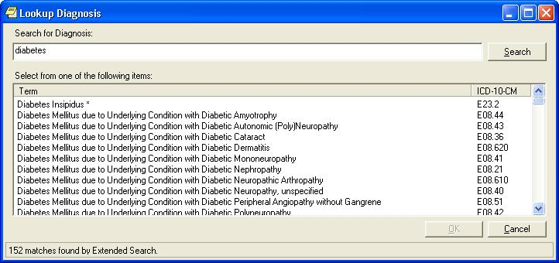
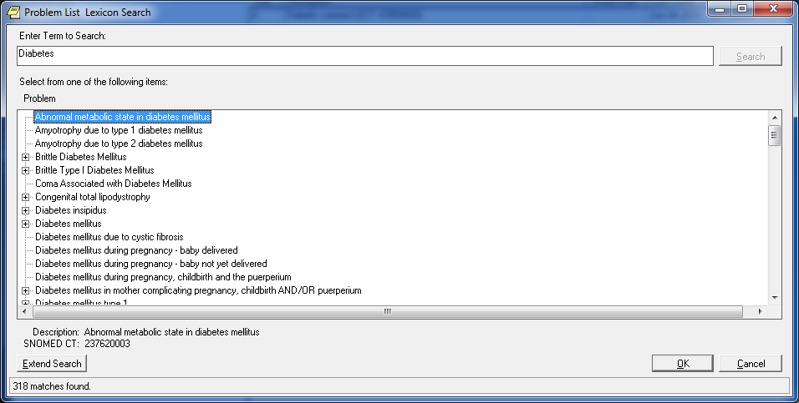

Users may use the following search methods:
  - Full SNOMED CT concept codes
  - Text strings (i.e. SNOMED CT description)

ICD diagnosis code search is prohibited on the Problems tab.
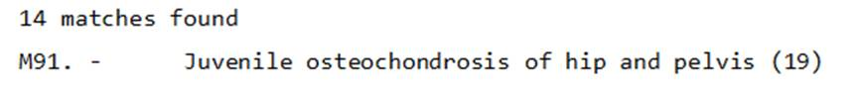

Add/Edit/Store ICD Diagnosis Code
- If the ‘Current System Date’ is on or after the ICD-10 activation date, the CPRS Problem List package will provide the ability to perform the following actions for ICD-10-CM diagnosis codes (problems) through the Action List items on the patient’s problem list.
  - New Problem: Add an active SNOMED CT diagnosis mapped to an ICD-10-CM diagnosis code of R69.
  - Change: Change an active SNOMED CT diagnosis mapped to an ICD-10-CM diagnosis code of R69.
  - Inactivate: Inactivate a SNOMED CT diagnosis mapped to an ICD-10-CM diagnosis code of R69.
  - Verify: Verify an active SNOMED CT diagnosis mapped to an ICD-10-CM diagnosis code of R69.
  - Annotate: Annotate and update an active SNOMED CT diagnosis mapped to an ICD-10-CM diagnosis code of R69.
  - Remove: Remove an active SNOMED CT diagnosis mapped to an ICD-10-CM diagnosis code of R69.
  - Restore: Restore an active SNOMED CT diagnosis mapped to an ICD-10-CM diagnosis code of R69.
  - View Details: Store an active SNOMED CT diagnosis mapped to an ICD-10-CM diagnosis code of R69.

Display ICD Diagnosis
- The CPRS Problem List allows for the display of problems for the Active View, Inactive View, and Removed View options within the initial Problem List.
  - The CPRS Problem List application will display an ICD-10 diagnosis short description within the initial Problem List screen and will label whether an ICD diagnosis code is either ICD-9 or ICD-10. (This applies to legacy problems and problems added through Clinical Reminders, PCE, and/or Group Notes.)

- When user selects the ‘View Details’ action, the CPRS Problem List application will:
  - Display the details of a SNOMED CT diagnosis mapped to an ICD-10-CM diagnosis code of R69 and its full descriptions/definitions
  - Print the SNOMED CT to ICD-10-CM diagnosis code audit history
- When using the “View Details” action, the CPRS Problem List application will display the ICD-10 label, ICD-10-CM diagnosis code, and short description within the audit history.

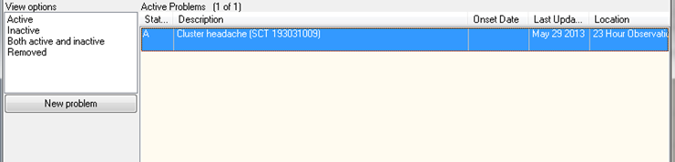
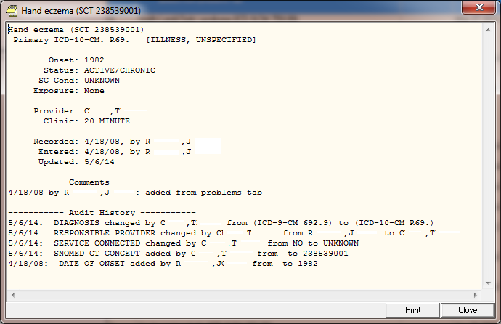

Print ICD Diagnosis
- When the user selects the ‘View Details’ action:
  - If the date the ICD diagnosis code was entered is on or after the ICD-10 activation date, the CPRS Problem List application will provide the ability to print the ICD-10-CM diagnosis codes and full descriptions/definitions.
  - The CPRS Problem List application will designate whether an ICD diagnosis code is ICD-9 or ICD-10.
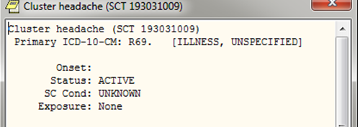

GMPL*2.0*44 - PROBLEM LIST ICD-10 CHANGES FOR CLINICAL REMINDERS

This build updates the Clinical Reminders Index cross-references in the Problem file (#9000011) to accommodate ICD-10 CM diagnosis codes. It restructures the Problem List portion of the Clinical Reminders Index to a generic format that can support ICD and SNOMED CT coding systems. This format is:
^PXRMINDX (9000011, CODING SYSTEM,”ISPP”, CODE, STATUS, PRIORITY, DFN, DLM, DAS)
^PXRMINDX (9000011, CODING SYSTEM,”PSPI”, DFN, STATUS, PRIORITY, CODE, DLM, DAS)
Where CODING SYSTEM is a three-character abbreviation as defined in the Coding Systems file (#757.03) and CODE is the code, not the pointer. For details, see the Clinical Reminders Index Technical Manual (PXRM_INDEX_TM).
The post-install routine will start a background job to rebuild the file #9000011 index in the new format.

GMPL*2*36 - EXTENSIONS TO ACCOMMODATE SNOMED-CT

The purpose of this patch is to accommodate the use of the Systematic Nomenclature of Medicine -- Clinical Terms (SNOMED CT) for selection of Patient Problems, and to dovetail with the efforts of Standard Data Service (SDS) to implement SNOMED CT on both the Enterprise Terminology Server and the Clinical Lexicon, using the New Term Rapid Turnaround (NTRT) strategy for vetting and deployment of novel clinical expressions.

This patch introduces changes required by CPRS v29 for selection of Patient Problems using SNOMED CT.

A new bulletin, GMPL PROBLEM NTRT BULLETIN, is added by the patch. This bulletin is sent to members of the FORUM mail group g.PROBLEM LIST NTRT when a SNOMED CT Concept is selected by the user for which no ICD-9-CM codes are mapped. The mail group is populated with members of OI&T’s Standards and Terminology Service. When approved by the Domain Steward for Problem List, new standardized mappings will be deployed using the New Term Rapid Turnaround capability.

Two new options are included:

Problem List NTRT Follow-up Report
This report allows sites to evaluate problems with valid SNOMED CT Concept codes, which were unmapped to ICD at the time of entry.

The report may be filtered by Medical Center Division, Provider(s), and Time Interval.

Problem List Freetext Follow-up Report
This report allows sites to evaluate uncoded free text problems that have been entered by one or more providers over a specified time interval.

GMPL*2*41 - CORRECT WINDOWS REPORT FOOTER
This patch corrects the printing of inaccurate CBOC division information in the footer section of the Patient Problem List report which is printed from the Problems Tab in the CPRS GUI.

GMPL*2*39 - FIX FOR GENERAL ERRORS IN PROBLEM LIST
This patch addresses the following issues:

1. A diagnosis entered on the Diagnosis Tab of the Encounter Form on the Notes Tab of CPRS GUI is not added to the problem list for inpatients whose hospital location type is "Clinic".

2. A CPRS GUI user at a non-VA site entering a new problem list item while entering an encounter for a patient will generate an undefined variable error when saving the form. This will cause all of the just entered data for the encounter to not be saved.

GMPL*2*38 - Fix for Problem List Priority Value
This patch fixes a problem with the problem list priority field always being set to a value of "Unknown". This can happen when the user is adding a new problem list entry to the patient chart, or when editing an existing problem list entry. If the user picks a priority of "Acute" or "Chronic" when adding or editing a problem list entry, the entry is saved to the PROBLEM file with a priority of "Unknown". This will only happen to Problem tab entries that were added or edited after GMPL*2.0*37 was installed on the system.

A site can use FileMan to find a list of entries that were added or modified after GMPL*2.0*37 was installed on the system.

GMPL*2*37 - PROBLEM LIST REPAIR DUE TO SHAD
When entering a new problem in CPRS 27 with an Immediacy of "<unknown>" a zero was entered in the PRIORITY field of the PROBLEM File, file #9000011. The Priority field should be null for an unknown problem. Having a zero value in the PRIORITY field created a bad entry in the Clinical Reminder Index that caused Clinical Reminders to incorrectly evaluate ICD9 data that is stored in the PROBLEM File.

This patch contains two fixes to address this problem: a change to GMPLSAVE to evaluate the data that is being passed to this routine. If CPRS passes a zero value for the Priority field GMPLSAVE will set the Priority field to null.

A post-install routine will evaluate the PROBLEM file, for entries that contain a zero in the Priority field. If any entries in the PROBLEM file, contains a zero the Priority field will be set to Null and the entry will be corrected in the Clinical Reminder Index. A mailman message will be sent to the person installing this patch. The message will list out the number of entries that contain a zero value in the priority field. The number of entries that were corrected and a final check to make sure that all the bad entries were corrected.

GMPL*2*35 - ADD SHAD AND CV TREATMENT FACTORS TO LEGACY VISTA
This patch is being released in conjunction with CPRS GUI v27. CPRS GUI version 27 consists of two host files: OR_PSJ_PSO_27.KID and CPRS_BUNDLE_GUI_27_REQ_REL.KID. These two host files contain software patches that support CPRS GUI v27 functionality. The host files were created to simplify installation at Veterans Health Administration (VHA) facilities.

GMPL*2*33 - USERS UNABLE TO VIEW INACTIVE ICD9 CODES
This patch addresses the problem where users were unable to modify current Problem Category Lists to make it assignable. The users cannot tell if the code is Inactive.

GMPL*2*32 - GMPL*2*31 INFORMATIONAL FOLLOW_UP
Included in patch GMPL*2*31 was a clean-up routine GMPL31P. This routine searched out bad ICD9 (file 81) pointers in the PROBLEM LIST file and PROBLEM LIST AUDIT entries. For pointers that included the "~", the "~" was removed and the remaining value was left. If a "-1" was found the pointer to the default ICD9 code 799.99 was put in the place of the "-1".

GMPL*2*31 - CORRECT DIAGNOSIS PTR UPDATE IN PROBLEM LIST
This patch corrects the problem of invalid characters (~) appearing in the DIAGNOSIS (pointer to the ICD DIAGNOSIS file #80) in the PROBLEM FILE (9000011). This modification will also add a check for the ICD code not being found. (-1 being returned instead of pointer from ICD #80 file search) The problem occurs when adding a problem or changing a problem via the CPRS GUI.

This patch also adds code that will record an audit trail when a Problem comment is modified.

GMPL*2.0*28 - CSV – Problem List Compliance

The following functionality has been added to Problem List in support of the Code Set Versioning project:
- Evaluation of problems on the active problem list to identify those entries with codes that are inactive for the current date.
- Display of problems with inactive codes.
- Prompts to edit problem list entries with codes that are inactive for the current date.
- Modifications of Lexicon Search Utility to display diagnoses that have active ICD9 codes for the current date. Only items that have active ICD9 codes for the current date will be selectable.

See page 14 for more detailed information of this CSV Compliance functionality.

GMPL*2.0*26 and GMTS*2.7*52 - CPRS/Problem List Enhancements
These patches added the following enhancements to Problem List and Health Summary:
- The CPRS List Manager displays Head and Neck Cancer in the Problem List for veterans diagnosed with cancer of the head and/or neck related to nose and throat radium treatment.
- The CPRS Health Summary displays Head and Neck Cancer for veterans diagnosed with cancer of the head and/or neck related to nose and throat radium treatment.
- The CPRS GUI displays Head and Neck Cancer in the Problem List for veterans diagnosed with cancer of the head and/or neck related to nose and throat radium treatment.
- (Available in CPRS v20) The CPRS GUI enables a user to indicate on the problem list that a veteran has cancer of the head and/or neck that is related to nose and throat radium treatments.
- (Available in CPRS v20) Upon indicating Head and Neck Cancer on the Problem List, the CPRS GUI associates related services categories to this diagnosis.
- (Available in CPRS v20) The CPRS GUI Problem List Clinic Report (remote data view) displays associated related service categories for a diagnosis of head and neck cancer that is indicated on the problem list.

See examples later in this manual for entering MST and Head and/or Neck Cancer conditions.

GMPL*2.0*27 - Clinical Reminders Index

This patch supports the Clinical Reminders Index (PXRM*1.5*12), whose goal is to create a new global in the Clinical Reminders namespace, ^PXRMINDX, that is an index of clinical data. Each of the packages whose data Clinical Reminders uses as a finding type is participating in this project.

GMPL*2.0*26 - Head-Neck Cancer/Military Sexual Trauma
This patch is in response to the Veterans Millennium Health Care and Benefits Act, Copayment Exemptions Software Requirements Specification, dated February 4, 2002. Special Conditions have been added to the Problem List for:

Head and/or Neck Cancer
Military Sexual Trauma

Problem List Patches

Patch # | Description | Release Date
GMPL*2*1 | Form Number in Footer | 02/09/95
GMPL*2*2 | PGMOV error in Report | 02/02/95
GMPL*2*3 | ALLOC Error/Duplicates/AICS API | 12/06/95
GMPL*2*4 | Fixes Encounter Form/PL Interface | 12/15/95
GMPL*2*5 | Fix UNDEFs in GMPLPREF & GMPLEDT4 | 03/07/96
GMPL*2*6 | Fix PCE Interface | 03/18/96
GMPL*2*7 | Problem List/ Lexicon | 10/04/96
GMPL*2*8 | Stop Duplicate Probl | 10/03/96
GMPL*2*9 | Duplicate Problems w | 11/01/96
GMPL*2*10 | CPRS INTERFACE | 07/07/98
GMPL*2*11 | Viewing Selections | 09/09/97
GMPL*2*12 | REMOVE DUPLICATE PRO | 07/07/99
GMPL*2*13 | ACUTE PROBLEM *'S NO | 11/12/98
GMPL*2*14 | NEW API FOR PROBLEM | 02/11/99
GMPL*2*15 | API FOR PROBLEM LIST | 05/05/99
GMPL*2*16 | INCONSISTENT PROVIDE | 09/29/99
GMPL*2*17 | EDITING PROBLEM LIST | 09/29/99
GMPL*2*18 | ADD AUDIT TRAIL TO O | 09/29/99
GMPL*2*19 | NEW API VARIABLE (PR | 02/07/00
GMPL*2*20 | PROBLEM LIST WARNING | 08/16/00
GMPL*2*21 | PROBLEM LIST COMMENT | 05/15/00
GMPL*2*22 | Add Lexicon Problem | 05/15/00
GMPL*2*23 | MODIFIED CROSS REFERENCE | 05/15/00
GMPL*2*24 | Run an ICD9 code 799 | 01/18/01
GMPL*2*25 | Undefined GMPLCOND Variable | 03/01/02
GMPL*2*26 | Head-Neck Cancer/Military Sexual Trauma | 05/24/02
GMPL*2*27 | Clinical Reminders Index | 11/04
GMPL*2*28 | CSV – Problem List Compliance | 08/15/03
GMPL*2*31 | CORRECT DIAGNOSIS PTR UPDATE IN PROBLEM LIST FILE | 5/05
GMPL*2*32 | GMPL*2*31 INFORMATIONAL FOLLOW_UP | 10/05
GMPL*2*35 | ADD SHAD AND CV TREATMENT FACTORS TO LEGACY VistA | 8/08
GMPL*2*36 | EXTENSIONS TO ACCOMMODATE SNOMED-CT | 5/13
GMPL*2*37 | PROBLEM LIST REPAIR DUE TO SHAD | 11/08
GMPL*2*38 | Fix for Problem List Priority Value | 2/09
GMPL*2*39 | FIX FOR GENERAL ERRORS IN PROBLEM LIST | 11/11
GMPL*2*41 | CORRECT WINDOWS REPORT FOOTER | 11/10
GMPL*2*44 | ICD-10 Remediation related to Clinical Reminders | 7/24/2014
GMPL*2*42 | ICD-10 Remediation | 8/5/2014

Orientation

How to Use this Manual

1. Make sure you know how to log on, navigate among menus and options, and respond to prompts for data entry. If necessary, ask your Application Coordinator or an IRM staff member to help you. The DHCP User’s Guide to Computing provides basic information about general computing and your computer system.

2. Review the Preface, the Table of Contents, and the Introduction in this manual, to understand the organization of Problem List and this manual.

3. If you are the application coordinator, review the Operation section, and, if desired, copy and distribute the appropriate sections to individual users, according to the menus assigned by IRM/ADPAC personnel.

4. Review the following pages in which we describe special keys and commands used in VistA and the Problem List, as well as style conventions used in this manual.

VistA, Problem List, List Manager, and CPRS/Windows Conventions

Problem List uses the same conventions (in its List Manager and terminal-based version) as Lab, Pharmacy, and other VistA packages. Only a few of the special keys and commands are described here. See the User’s Guide to Computing, for more complete lists of conventions. Problem List in CPRS follows standard Windows and VistA GUI standards and conventions.

Keep in mind that these keys and commands vary somewhat according to the kind of terminal you are using. Also note that your hospital IRM staff or the clinical coordinator can change menus (and even some of the prompts) to fit your hospital needs.

<Enter> The symbol used in computer dialogue examples for the return key. On some keyboards this is the ENTER key or the key with the symbol ↵. Enter <Enter> (press the return key) after every response you enter or when you wish to bypass a prompt, accept a default (//), or return to a previous action.
? If you enter a question mark after a prompt, the computer will display instructions or a list of choices for responding to that prompt.
?? Two question marks will usually cause more detailed instructions to appear, or a list of choices.
// Double slashes mean a default response has been provided. This will either be the most likely choice, a previously entered response, or the least harmful choice. (Ex.: Are you sure you want to remove this problem? NO//) If you wish to select the default response (NO), just press the return key (indicated in this manual by <Enter>). Otherwise enter a different choice.
+ The plus sign moves the screen to the next screen.
- The minus sign moves you back to the previous screen.
^ A single up-arrow, if allowed, terminates a series of questions and returns you to a previous level. You may need to enter ^ several times to exit the program or return to the level you wish. If you want to return to a previous prompt or option, enter ^ and the name of the desired prompt or option.
^(#) will take you back to an earlier problem when the problem you are adding has more than five matches (see the Helpful Hints section in this manual for an example).
$ A dollar sign next to a problem on the problem list indicates that a clinician needs to verify a transcribed problem.
* An asterisk next to a problem indicates that it has been designated an acute problem.
( ) Parentheses around an action mean that you can’t select that action in that context. For example, if a patient has no active problems, you cannot choose the action Edit a problem.

Conventions used in this manual

• Option examples: Menus and examples of computer dialogue that you see on the CRT screen are depicted here in boxes:

Select Problem List Menu Option: pl Patient Problem List
Select PATIENT NAME: PLPATIENT,ONE 03-04-14 666123432 NSC VETERAN

Searching for the patient's problem list...

- CPRS GUI Examples:
Examples of Problem List in CPRS are graphic captures such as the following:

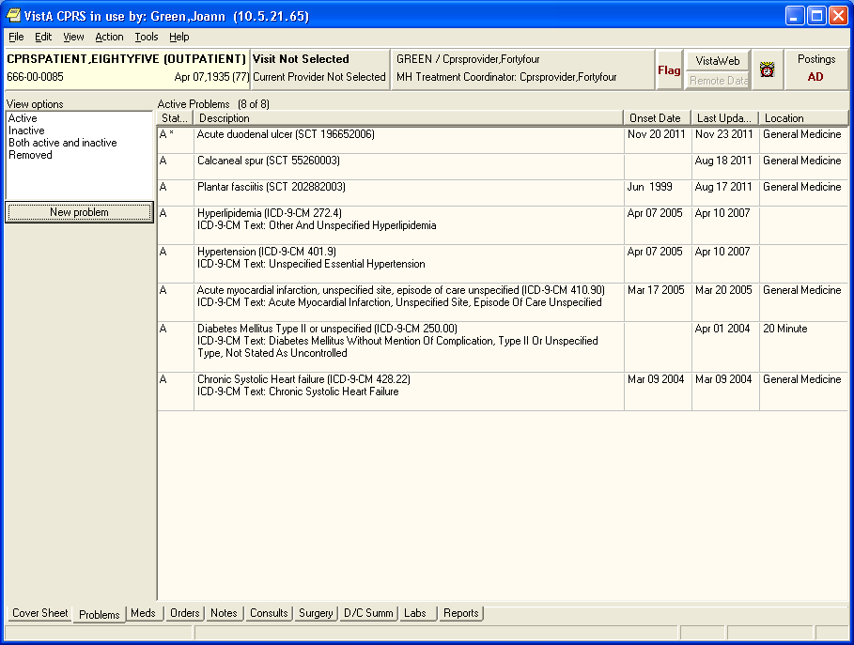

PLPROVIDER,TWO
PLPROVIDER,TWO
PLPROVIDER,TWO
PLPROVIDER,TWO
PLPROVIDER,TWO
PLPROVIDER,TWO

• Reports or Printouts: Reports are depicted here in double-lined boxes:
--------------------------------------------------------------------------------
PLPATIENT,TWO (P3333) | PROBLEM LIST
--------------------------------------------------------------------------------
Prob Date Date of Date
No. Recorded Active Problems Onset Resolved
--------------------------------------------------------------------------------
1. 2/9/04 Peripheral Vascular Disease Leg/Foot 1991
Due to diabetic neuropathy and old football injury

2. 2/9/04 Cholecystitis 1991 1972

3. 2/9/04 Intermittent Claudication 7/92
R profunda femoris occlusion - 90%

• User responses: In computer dialogues, the user response is in boldface.

Select NEW PERSON NAME: PLPROVIDER,ONE

NOTE: You can respond to many prompts by typing the first few letters of a name, option, or action.

• Option Selection: Some option names have “mnemonics,” an abbreviation that you can enter rather than the entire option name. Since sites frequently assign their own numbers or letter abbreviations to options, we use the first letter or letters for selecting options in the examples in this manual.

• Explanations: Special notes are in a box, preceded by a pointing finger:

Note:   | A list must be defined before you can use this option.

+ NOTE:

• Problem Selection: When you are prompted to select a problem from a range of problems (e.g., Select Problem(s) (1-5)), you may select one item or more by using commas or a range of items separated by a dash.

List Manager Conventions

• List Manager Screen Display: The List Manager utility allows Problem List (and other applications) to maintain the header and action portion of a list, while the center display (for example, the problems or the detailed display) scrolls. So if a patient has too many problems to fit within the scrolling portion of the screen, pressing the return key causes that portion of the screen to scroll up while the top and bottom stay unchanged.

Select PATIENT NAME: PLPATIENT,THREE 03-04-14 6666432432 NSC VETERAN

Searching for the patient's problem list...

PROBLEM LIST Apr 09, 2002@15:22:08 Page: 1 of 1
PLPATIENT,THREE (P2432) 1 active problems
ACTIVE PROBLEMS
Problem Updated Clinic
1 Asthma Bronchial, Onset 1997 4/9/02 LAB-MENTAL HEALTH

+ Next Screen - Prev Screen ?? More actions
AD Add New Problems IN Inactivate Problems VW Select View of List
RM Remove Problems CM Comment on a Problem SP Select New Patient
ED Edit a Problem DT Detailed Display PP Print Problem List
Q Quit
Select Action: Quit// ED Edit a Problem

The highlighted bar in the middle contains instructions about actions you can take.

For example:
You can type + to move forward or - to move back. To see a list of navigation actions, type two question marks (??) at the Select Action prompt.

Windows Conventions

See the CPRS online help or the SACC GUI Conventions (available at: http://vista.med.va.gov/sacc/docref.html

Package Management

Implementation of Problem List

After installing Problem List, other implementation steps are mostly optional. These include:

1. Assigning menus and options (required)

2. Assigning the security key (optional)

3. Editing site parameters (optional)

4. Setting User Preferences (optional)

5. Creating selection lists (optional)

6. Creating Encounter Forms (optional)

All functions except #6 are described in the following pages of the Package Management section. See the Encounter Form Utilities Module User Manual (part of the Integrated Billing V. 2.0 documentation set) for instructions about creating Encounter Forms to use with Problem List. Also see CPRS documentation for further information about using Problem List through CPRS (either the List Manager or the GUI version).

Package Management

Links to other packages

Problem List is closely linked to other applications: Lexicon Utility, Computerized Patient Record System (CPRS), Data Standardization/Near Term Rapid Turnaround Time (NTRT, Encounter Form (part of Integrated Billing), Health Summary, and Patient Care Encounter (PCE). This linkage should remain transparent to users, but the IRM office and Clinical Coordinators will need to work closely to coordinate all the components. See the User and Technical Manuals of these packages for further instructions, such as how to build an encounter form for your hospital.

Lexicon

The Lexicon Utility can be modified to meet local site needs (for example, to allow nurses to see only nursing terms). See the Appendix in this manual and the Lexicon Utility documentation for information on customizing this package for use with the Problem List application.

Encounter Forms

Encounter Forms (scannable or otherwise) can be used by clinicians and clerks for data entry of problems into the Problem List. See the Appendix in this manual and the Encounter Form Utilities User Manual (part of the Integrated Billing 2.0 documentation set) for further information.

CPRS

Since the release of CPRS in 1999, many sites now use Problem List through the List Manager or GUI version of CPRS, which allows a more integrated view of the patient record. The cover sheet of CPRS displays a patient’s current problems (site or user-configurable) and allows the clinician to click on any of these for immediate information. The Problem tab allows entry, edit, and display of problems.

Menu Access

Assign menus and options as follows:

Common Name | Technical Name | Who
Assign ICD Diagnoses to Problem List | GMPL CODE LIST | PIMS Clerks, Clinical Coordinators (CACs)
Patient Problem List | GMPL CLINICAL USER | Clinicians, Nurses, Clinical Coordinators (CACs)
Problem List Data Entry | GMPL DATA ENTRY | PIMS Clerks, Clinical Coordinators (CACs)
Problem List Mgt Menu | GMPL MGT MENU | IRMS, Clinical Coordinators (CACs)
Problem List User Preferences Menu | GMPL USER PREFS MENU | Clinicians, Nurses, IRMS, Clinical Coordinators (CACs)

Security Keys

Problem List has one security key – GMPL ICD CODE – which is used by the Problem List package to determine if the current user is trained and authorized to code provider text to the ICD Diagnosis codes. It is intended for PIMS Coding Clerks.

Electronic Signature

Problem List doesn’t use electronic signature.

Legal Requirements

There are no specific legal requirements for Problem List.

Code Set Versioning (CSV) Requirements

Functionality has been added to Problem List in support of the Code Set Versioning project.

Problem List is available in two places:
- CPRS GUI Problem List tab
- List Manager Problem List

Both of these provide functionality to enter and manage problems associated with the patient, and all will evaluate problems on the active problem list to identify those entries with codes that are inactive for the current date.

ICD-10 Project
NOTE: With the ICD-10 project, many changes have been made to Problem List and the Lexicon utility, some of which may override Code Set Versioning requirements described here.

The following functionality was added to Problem List in support of the Code Set Versioning project:

Problem List in List Manager

- Evaluates problems on the active problem list to identify those entries with codes that are inactive for the current date.
- Provides a method to display to the user the identified problems with inactive codes.
- Prompts the user to edit problem list entries with codes that are inactive for the current date.
- Uses the Lexicon Search Utility and displays diagnoses that have active ICD9 codes for the current date. Only items that have active ICD9 codes for the current date will be selectable.

Adding a Problem
- When adding a new problem, Problem List uses the Lexicon Search Utility and displays diagnoses that have an active ICD9 code for the current date. Only items that have active ICD9 codes for the current date will be selectable.
- If the user or clinic has a Problem Selection List assigned, Problem List displays only items that have active ICD9 codes for the current date.

Changing a Problem
- When changing a problem, Problem List uses the Lexicon Search Utility and display diagnoses that have active ICD9 codes for the current date. Only items that have active ICD9 codes for the current date will be selectable.

Saving a Problem
- When the problem is saved, Problem List evaluates the problem code to ensure that it has an active ICD9 code for the current date. If the code is not active, an error message will be displayed to the user.

Commenting on a Problem
- When adding a comment to a problem, Problem List evaluates the code associated with the problem. If the code is inactive for the current date, an error message will be displayed to the user stating that the code is not active for the current date and ask the user to edit the problem.

Verifying a Problem
- When verifying a problem on the Problem List, Problem List evaluates the code associated with the problem. If the code is inactive for the current date, OE/RR will display a message to the user stating that the code is not active for the current date and ask the user to edit the problem.

Problem List Selection Lists and Categories
- Problem Selection List functionality was modified to ensure that all selectable problems have an active ICD9 code for the current date.
- Problem Selection Lists can be assigned to a user or to a clinic. If a Problem Selection List is defined for a user or a clinic, CPRS GUI uses the list on the CPRS GUI Problems Tab. In addition, OERR List Manager displays the list on the OERR List Manager Problems Tab, and Problem List also uses it. In each interface, the list is displayed as a default common Problem List when a new problem is added.
- Problem List evaluates entries on the Problem Selection List and identify problems with inactive ICD9 codes.
- When adding a problem to a Problem Category, Problem List allows selection of problems that have an active ICD9 code for the current date.

- When editing a problem included in a Problem Category, Problem List allows selection of problems that have active ICD9 codes for the current date.
- When adding a Problem Category to the Problem Selection List, Problem List evaluates the problems in the Problem Category. If a problem has an inactive code, the Problem Category will not be added to the Problem Selection List, an error message advising the user to edit the entries with inactive codes will be presented to the user, and the user will be returned to the EDIT PROBLEM CATEGORY screen.
- When saving the Problem Selection List, Problem List evaluates the problems for an active ICD9 code for the current date. If an entry has an inactive code, the list will not be saved, an error message advising the user to edit the entries with inactive codes will be presented to the user, and the user will be returned to the EDIT PROBLEM CATEGORY screen.
- When assigning the Problem Selection List to a user or to a clinic, Problem List evaluates the problems for an active ICD9 code for the current date. If an entry has an inactive code, the list will not be assigned, and an error message will be displayed to the user. The error message states that a problem selection list with an inactive code may not be assigned to a user or a clinic.
- When assigning new ICD9 codes to a problem, Problem List allows selection of codes that are active for the current date.
- Problem List developed a protocol that subscribes to the new Lexicon Code Set Update Protocol Event and to the ICD Code Set Update Protocols. This protocol is a background job that is activated when a new ICD-9 code set version is implemented.
- When a new ICD9 code set version is implemented, Problem List evaluates the entries in PROBLEM SELECTION CATEGORY CONTENTS file (#125.12) for codes that have been inactivated.
- Problem List identifies any selection list problem with an ICD9 code that has been inactivated.
- Problem List generates a report that identifies the Problem Categories and Problem Selection Lists that include problems with inactivated codes.
- Problem List sends a MailMan message to notify CACs of Problem Selection Lists with problems that have inactive codes. The message will include the report that identifies the Problem Categories and Problem Selection Lists that include problems with inactivated codes. The CACs will be advised to update the problems with inactivated codes.

An example of information that is included in the message sent to CACs is included below:
ICD-9 CODE SET EFFECTIVE MM/DD/YY
Problem List Post Installation Processing for:

PROBLEM SELECTION CATEGORY CONTENTS file (#125.12).
Started Processing: date/time seconds
Ended Processing: date/time seconds

Total PROBLEM CATEGORIES with inactivated problems: nn
Total PROBLEM SELECTION LISTS with inactivated problems: nn

Effective MM/DD/YY, Problem Categories reported below will include problems that have inactivated codes. Please edit the PROBLEM CATEGORIES reported below.

IEN Problem Category Problem Selection List
============================================
xxx xxxxxxxxxxxxxxx xxxxxxxxxxxxxxxxxxxx

- Problem List developed a new option for CACs and IRM staff to manually initiate evaluation of the PROBLEM SELECTION CATEGORY CONTENTS file (#125.12) for inactivated ICD9 codes. This option performs similar actions as the Problem List ICD9 Code Set Update Protocol. It is manually initiated rather than electronically triggered.

- Problem List evaluates the entries in PROBLEM SELECTION CATEGORY CONTENTS file (#125.12) and identifies any selection list problem with a code that has been inactivated.

- Problem List will generate a report that identifies the Problem Categories and Problem Selection Lists that include problems with inactivated codes.

Example of information that is included in the report:
ICD-9 CODE SET EFFECTIVE MM/DD/YY
Problem List Post Installation Processing for:

PROBLEM SELECTION CATEGORY CONTENTS file (#125.12).
Started Processing: date/time seconds
Ended Processing: date/time seconds

Total PROBLEM CATEGORIES with inactivated problems: nn
Total PROBLEM SELECTION LISTS with inactivated problems: nn

Effective MM/DD/YY, Problem Categories reported below will include problems that have inactivated codes. Please edit the PROBLEM CATEGORIES reported below.

IEN Problem Category Problem Selection List
============================================
xxx xxxxxxxxxxxxxxx xxxxxxxxxxxxxxxxxxxx

CPRS GUI Problem List Tab

- The same "#" symbol is displayed in the "Status" column next to problems associated with a currently inactive code. Upon first displaying the list, a message will be displayed to the user if any such problems have been found.
- Entry of a new problem only allows selection of ICD codes that are active as of the current date. This applies both to the lexicon lookup and to the predefined list of selectable problems and categories.

- Any action taken on an active problem having an inactive ICD code first requires correction/update of that code via the "Change" action.

Add Problem (ICD9 Code)
- When adding a new problem, CPRS GUI uses the Problem List Lexicon Search Utility and display diagnoses that have active ICD9 codes for the current date. Only items that have active ICD9 codes for the current date are selectable.
- If the user or clinic has a Problem Selection List assigned, CPRS GUI displays only items that have an active ICD9 code for the current date.

Annotate Problem
- When adding a comment to a problem, CPRS GUI evaluates the code associated with the problem. If the code is inactive for the current date, CPRS GUI displays an error message to the user stating that the ICD9 code is not active for the current date and advise the user that the problem can be edited using the change action.

Verify Problem
- When verifying a problem, CPRS GUI evaluates the code associated with the Problem. If the ICD9 code is inactive for the current date, CPRS GUI displays an error message to the user stating that the ICD9 code is not active for the current date and advise the user that the problem can be edited using the change action.

Restore Problem
- When replacing a removed problem, CPRS GUI evaluates the ICD9 code associated with the problem. If the ICD9 code is inactive for the current date, CPRS GUI displays an error message to the user stating that the ICD9 code is not active for the current date and then present the user with the change problem screen.

Change Problem (ICD9 Code)
- When changing a problem, CPRS GUI uses the Problem List Lexicon Search Utility and displays diagnoses that have active ICD9 codes for the current date. Only items that have active ICD9 codes for the current date are selectable.
- When the problem is saved, CPRS GUI evaluates the problem code to ensure that it has an active ICD9 code for the current date. If the code is not active, an error message is displayed to the user.

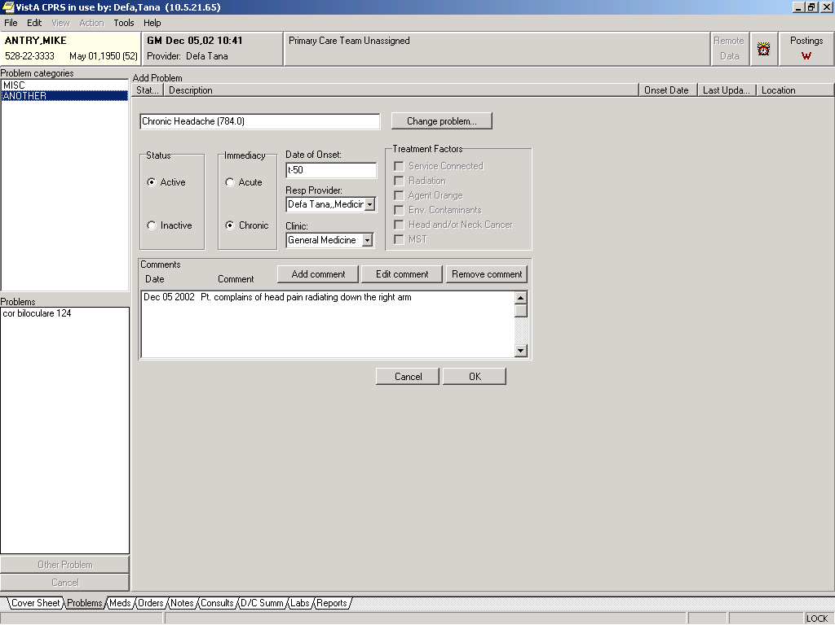
CPRSPATIENT,ONE
666-00-1111
PLPROVIDER,ONE

- CPRS prompts the user to change problem list entries with ICD9 codes that are inactive for the current date. CPRS uses the Problem List Lexicon Search Utility and display diagnoses that have active ICD9 codes for the current date. Selection of diagnoses requires active ICD9 codes for the current date.

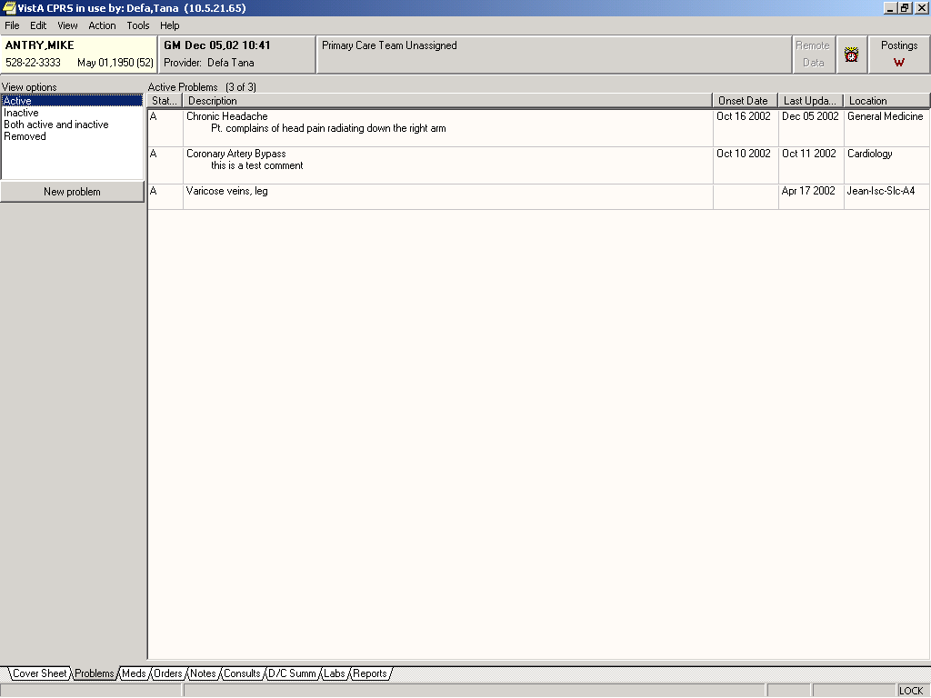
PLPROVIDER,ONE
PLPATIENT,ONE
666-00-1111

CPRS Problem List Management

When Problem List is used through CPRS, several CPRS parameters can be set that affect the use of Problem List.

Initial Tab and Cover Sheet Parameters
The tab that displays first when a user starts CPRS may be set by the parameter ORCH INITIAL TAB. This parameter may be set for the site and then overridden at the division and user levels, as needed. If no value is set, the chart will open, by default, to the Cover Sheet. ORCH INITIAL TAB may be set to the following values:
1 Cover
2 Problems
3 Meds
4 Orders
6 Notes
7 Consults
8 DC Summ
9 Labs
10 Reports

Note: | The number 5 is not one of the possible values. It is reserved.  Additionally, CPRS may be configured to remain on the same tab when the user changes to another patient record. Setting ORCH USE LAST TAB to “yes” will accomplish this. If ORCH USE LAST TAB is set to “no” or not set, the chart will always open to the tab identified by ORCH INITIAL TAB when changing patients.

The criteria for determining what gets loaded into each section of the cover sheet are determined by parameter settings. To set Cover Sheet parameters, use the “CPRS Configuration (Clin Coordinator)” menu option then “GUI Parameters” and then “GUI Cover Sheet Display Parameters” on the CPRS Configuration menu to set Cover Sheet parameters. These parameters may be set for the system, a division, a service, a location, or an individual user. For Problem List, Currently active problems are shown in the list.

Problem List Default Views
The user’s default view on the Problems tab is determined by two different settings. Both the GUI and the List Manager versions of CPRS use the ORCH CONTEXT PROBLEMS parameter. Its value can be set at the SYSTEM and USER levels. The parameter takes the form of a semicolon-delimited string, with the different pieces’ meaning as follows:
a;b;c;d;e (example: T-180;T;A;1;1329)
a Begin date
b End date
c Status (A = active, I = inactive, B = both, R = removed)
d If “1”, show all comments as default
e Provider internal entry number
The user-level value for this parameter can be set using the View | Filter menu and saving the selected settings as the default. There should be no need to edit the parameter directly at the user level.

Both the GUI and List Manager versions of CPRS use the PROBLEM LIST PRIMARY VIEW field (#125) of the NEW PERSON (#200) file. The contents of the field determine whether the outpatient (clinics) or inpatient (services) view of the problem list will be used, and can also be used to specify clinics or services to include in the list. The field will contain a “C” or “S,” followed by a list of internal entry numbers of clinics and services, separated by a forward slash (/ ) and ending with a trailing forward slash. Here is an example, excerpted from a VA FileMan INQUIRE into the NEW PERSON file for a user:
PROBLEM LIST PRIMARY VIEW: C/4/5/
“C” indicates outpatient (Clinics) view should be used. “S” indicates that the inpatient (Services) view should be used. “4” and “5” are pointers to default clinics or services (depending on “C” or “S”) to include in the view. Others will be hidden. If none are specified, all will be shown.
For users of the GUI, it is best to use the View | Filter menu to set this field. Save as Default will update it with the selected view and clinics or services to include. Since it is stored in the NEW PERSON file, it is applicable only to the individual user.

User Access and Privileges
If the user holds any of the ORES/ORELSE/PROVIDER keys, that user is viewed as a clinical user, and has full access privileges to all problem list options. If a user holds the OREMAS key, that user is viewed as a clerical user. In that case, the Verify, Remove, Restore, and View Removed options will not be available. If the site parameter requiring verification is set to TRUE, then problems entered will be left in an UNVERIFIED state until a clinical user verifies them. Problems in the UNVERIFIED state are denoted by a dollar sign ($) inserted at the beginning of the line.

These access levels are also enforced when problems are entered via the encounter form. Problems entered on the encounter form by clerical personnel will be left as UNVERIFIED.

CPRS List Manager and the Problem List package do not operate exactly the same as described above. The Problem List package evaluates the presence/absence of menu options in the user’s menu tree, and determines access accordingly. Since CPRS LM sometimes drops into PL package code, it uses a hybrid method of keys and menu options to determine access.

Management Menu Options

Problem List Mgt Menu [GMPL MGT MENU]

1 Patient Problem List
2 Edit PL Site Parameters
3 Create Problem Selection Lists ...
1 Build Problem Selection List(s)
2 Copy Selection List from IB Encounter Form
3 Assign Selection List to User(s)
4 Remove Selection List from User(s)
5 Delete Problem Selection List
4 List Patients with Problem List data
5 Search for Patients having selected Problem
6 Replace Removed Problem(s) on Patient's List
7 Problem List NTRT Follow-up Report
8 Problem List Freetext Follow-up Report

Patient Problem List is described in the Package Operation section of this manual.

Note: | Problem List NTRT Follow-up Report and Problem List Freetext Follow-up Report are new with GMPL*2*36.

Edit PL Site Parameters

[GMPL PARAMETER EDIT]

These site parameters are stored in the Problem List Site Parameters file #125.99.
This option lets you set five site parameters:

- Place a flag on problems entered by clerks so that a clinician must review the problems and verify them. The flag will appear as a dollar sign ($).
- Prompt users to have a chart copy printed.
- Search the Lexicon Utility when adding to or editing a problem list. The Lexicon Utility provides standardized text and codes – ICD9, CPT, SNOMED, and other codes, if they’re available. If you choose not to use the Lexicon Utility, the Problem List will capture only the free text that is entered (the Provider Narrative) [NOTE: Not Recommended].
- Choose whether to display the patient problem list in chronological or reverse chronological order (most recent at top).
- Screen duplicate orders. If YES is entered in this field, duplicate problems (those having the same ICD9 code) will NOT be added to the problem list. The primary purpose of this field is to screen entries added via the scannable encounter form.

Select Problem List Mgt Menu Option: Edit PL Site Parameters
VERIFY TRANSCRIBED PROBLEMS: NO// YES
PROMPT FOR CHART COPY: YES, ASK// <Enter>
USE LEXICON UTILITY: YES// <Enter>
DISPLAY ORDER: CHRONOLOGICAL// REVERSE
SCREEN DUPLICATE ENTRIES: YES// <Enter>

You have PENDING ALERTS
Enter "VA VIEW ALERTS to review alerts

Select Problem List Mgt Menu Option: <Enter>

Follow these steps to set the Problem List parameters:

1. Go into the Problem List Mgt Menu.
2. Select Edit PL Site Parameters.
3. Type NO if you don’t wish to have transcribed entries flagged for clinician verification.
4. Type NO if you don’t wish to have the users prompted about whether they want to have chart copies printed.
5. Type NO if you don’t wish to use the Lexicon Utility to match the problem against a standardized term with corresponding codes (ICD9, etc.).
6. Type Reverse if you want your problems displayed in reverse chronological order (most recent at top).
7. Enter the @ sign if you don’t want to screen duplicate entries. Otherwise, press the enter key.

Create Problem Selection Lists [GMPL BUILD LIST MENU]

This menu contains options for creating and maintaining lists of commonly selected problems (sometimes called a “Pick List”). These lists can help speed up the process of using the Problem List.

After you have a selection list assigned to you, this list will appear on your screen whenever you want to add new problems for a selected patient. Lists may also be assigned to a clinic. If you don’t have an individual problem selection list assigned to you, but a list has been built for a clinic, this list will appear when adding problems for a patient associated with that particular clinic.

Problem Selection Lists Options:

1 Build Problem Selection List(s)
2 Copy Selection List from IB Encounter Form
3 Assign Selection List to User(s)
4 Remove Selection List from User(s)
5 Delete Problem Selection List

Option 1 allows you to:
• Create a pick list
• Add categories to it
• Add problems to the categories
• Assign the list to a user or clinic

The Clinical Coordinator can also use option 3 to assign selection lists to users, or users can assign their own lists through User Preferences.

Option 2 is intended for sites that are using the Integrated Billing Encounter Form. Selection Lists may be created for use on an Encounter Form, and these, in turn, can be copied into the Problem List application.

Create Problem Selection Lists [GMPL BUILD LIST MENU]

Category: A grouping with or without a header of related problems, such as Cardiology, Musculoskeletal, Vascular, Neurology, etc.

- A list is made up of one or more Categories, each of which contains several related problems.
- Categories can be re-used in other lists.

Problem Selection Clinic: The clinic you want to have associated with this list. Answer with a hospital location from the Hospital Location list, but only hospital locations that are clinics are allowed. Optional.

These are the steps to create a problem selection list from scratch. See the next pages for examples and step-by-step instructions on creating problem selection lists.

1. Create a new list by typing in a name at the Select LIST NAME prompt.

2. Create a new problem category using the action EC (Enter/Edit Category).

3. Add problems to the category using the action AD (Add Problems).

4. Continue to create more categories if you wish to have more on your list. Add problems to each category.

REMEMBER: You can respond to many prompts by typing the first few letters of a name, option, or action. Some option names have “mnemonics” — an abbreviation that you can enter rather than the entire option name.

Build Problem Selection List(s)

This option lets you create selection lists by creating one or more problem categories and adding the problems you want in each category.

New categories may be added to this list, or an existing category can be removed. Enter/Edit Category allows you to change the contents (problems) of a category, or create a new one that may be added to this list.

You may also change how each category appears in this list, view each category's sequence number to facilitate resequencing, assign this list to a clinic or user(s), or edit a different list.

Steps to use option:

1. Go into the Problem List Mgt Menu.

2. Select the Create Problem Selection Lists option.
If numbers are used for menu options, you can type in that number or the first letter(s) of the option.

3. Select Build Problem Selection List(s).

4. At the “Select LIST NAME” prompt, type the name of a new selection list by entering a new name.

5. Enter the Problem Selection Clinic.

Select Create Problem Selection Lists Option: 1 Build Problem Selection List(s)
Select LIST NAME: Dr. Provider's List
Are you adding 'Dr. Provider's List' as
a new PROBLEM SELECTION LIST (the 9TH)? No// y (Yes)
PROBLEM SELECTION LIST CLINIC: Cardiology
1 CARDIOLOGY1
2 CARDIOLOGY2
CHOOSE 1-2: 2 CARDIOLOGY
Searching for the list ...

BUILD PROBLEM SELECTION LIST Apr 29, 2002@10:46:52 Page: 1 of 1
Last Modified: <new list> 0 categories
Dr. Provider's List

No items available.

+ Next Screen - Prev Screen ?? More actions
AD Add Category to List SQ Resequence Categories VW View w/wo Seq Numbers
RM Remove Category CD Edit Category Display CL Change Selection Lists
EC Enter/Edit Category SS Assign List SV Save List and Quit
6. At the “Select Action” prompt, type EC to create a new Category.

7. Type a name for a category you wish to have on your list.

Select Action: Quit// EC
Select CATEGORY NAME: Cardiovascular
ARE YOU ADDING ‘Cardiovascular’ AS A NEW PROBLEM SELECTION CATEGORY (THE 1ST)? YES

The screen is then redisplayed, with a new list of actions for adding, removing, and editing problems.

Specialty Subset:
Because many discipline-specific terms are synonyms to other terms, they are not accessible unless you specify the appropriate subset of the Lexicon Utility to choose from. If you wish to build a problem selection list for a particular specialty, choose one of the following: Nursing, Dental, Social Work, Immunology, or General Problem.

After you have built one category containing problems, repeat the process to add more categories to your list.

Example: Adding problems to category
Searching for the list

BUILD PROBLEM SELECTION LIST Apr 29, 2002@10:46:52 Page: 1 of 1
Last Modified: <new list> 0 categories
Dr. Provider's List

No items available.

+ Next Screen - Prev Screen ?? More actions
AD Add Category to List SQ Resequence Categories VW View w/wo Seq Numbers
RM Remove Category CD Edit Category Display CL Change Selection Lists
EC Enter/Edit Category SS Assign List SV Save List and Quit
Q Quit
Select Action: Quit// ec Enter/Edit Category
Select CATEGORY NAME: Cardiovascular
Are you adding 'Cardiovascular' as
a new PROBLEM SELECTION CATEGORY (the 4TH)? No// y (Yes)
Searching for the problems ...

AD Add Problems SQ Resequence Problems SV Save Category and Quit
RM Remove a Problem DL Delete Category CC Change Categories
ED Edit Problems VW View w/wo Seq Numbers Q Quit

Select Item(s): Quit//
8. At the “Select Action” prompt, type AD for Add Problems.

9. Enter a Specialty Subset or a return to accept the default.

9. Type the name of a problem for this category.
If there is more than one match for this problem, choose the one you will see most frequently in your practice.

10. Accept the defaults for Display Text, ICD CODE, and SEQUENCE, or enter new values.

Select Item(s): Quit// ad Add Problems
Select Specialty Subset: GENERAL PROBLEM// <Enter>

PROBLEM: hypertension

74 matches found

1 Hypertension * (ICD-9-CM 401.9)
2 Benign essential hypertension (ICD-9-CM 401.1)
3 Ocular Hypertension * (ICD-9-CM 365.04)
4 Benign renovascular hypertension (ICD-9-CM 405.11)
5 Benign Hypertension (ICD-9-CM 401.1)

Type "^" to STOP or Select 1-5: 1

>>> Code : 401.9

DISPLAY TEXT: Hypertension// <Enter>
ICD CODE: 401.9// 401.9 HYPERTENSION NOS
...OK? Yes// <Enter> (Yes)

SEQUENCE: 1// <Enter>

11. Continue to enter all the problem names you want included in this category; then press return at the Problem prompt.

PROBLEM: obesity

16 matches found

1 Obesity * (ICD-9-CM 278.00)
2 Morbid Obesity * (ICD-9-CM 278.01)
3 Primary Obesity (ICD-9-CM 278.00)
4 Screening for Obesity (ICD-9-CM V77.8)
5 Froehlich's Syndrome (ICD-9-CM 253.8)

Type "^" to STOP or Select 1-5: 1

>>> Code : 278.00

DISPLAY TEXT: Obesity//<Enter>

ICD CODE: 278.00// 278.00 OBESITY, UNSP
...OK? Yes// <Enter> (Yes)
SEQUENCE: 2//

PROBLEM: <Enter>

EDIT PROBLEM CATEGORY Apr 29, 2002@10:55:51 Page: 1 of 1
Last Modified: <new category> 2 problems
Cardiovascular

1 Hypertension (401.9)
2 Obesity (278.00)

+ Next Screen - Prev Screen ?? More actions
AD Add Problems SQ Resequence Problems SV Save Category and Quit
RM Remove a Problem DL Delete Category CC Change Categories
ED Edit Problems VW View w/wo Seq Numbers Q Quit

Select Item(s): Quit//

12. If you want to create more categories, type CC for Change Categories, then enter a new category name at the “Select CATEGORY NAME” prompt, and repeat the previously described process.

Adding more categories
Select Action: CC Change Categories
Select CATEGORY NAME: Neurology
ARE YOU ADDING ‘Neurology’ AS A NEW PROBLEM SELECTION CATEGORY (THE 2nd)? y
Searching for the list ...

EDIT PROBLEM CATEGORY April 29, 2002 17:04:29 Page: 1 of 1
Last Modified: <new category> 0 problems
Neurology

No items available.

+ Next Screen - Prev Screen ?? More actions
AD Add Problems SQ Resequence Problems SV Save Category and Quit
RM Remove a Problem DL Delete Category CC Change Categories
ED Edit Problems VW View w/wo Seq Numbers Q Quit

Select Action: Quit// AD Add Problems
Select Specialty Subset: GENERAL PROBLEM// <Enter>
PROBLEM: Stroke
Searching...
The following 8 matches were found:

1: Cerebrovascular Accident (ICD 436.)
2: Heat stroke * (ICD E900.9)
3: Heat stroke and sunstroke (ICD 992.0)
4: Lightning Stroke (ICD 904.0/E907.)
5: Stroke (ICD 436.)
Select 1-5, '^<number>' to jump, '^' or <enter>: 5
DISPLAY TEXT: Stroke// <Enter>
ICD CODE: 436.// <Enter> 436. CVA COMPLICATION/COMORBIDITY
...OK? YES// <Enter>
SEQUENCE: 1// <Enter>

PROBLEM: Tourette's Syndrome
Searching ...
Tourette Syndrome * (ICD 307.23)
OK? Y// <Enter>
DISPLAY TEXT: Tourette Syndrome// <Enter>
ICD CODE: 307.23// 307.23 GILLES TOURETTE DISORDER
...OK? YES// <Enter>
SEQUENCE: 2// <Enter>
PROBLEM: Epilepsy
Searching ...
The following 42 matches were found:
1: Epilepsy * (ICD 345./345.9)
2: Epilepsy NEC (ICD 345.8)
3: Epilepsy, Partial * (ICD 345.5)
4: Epilepsy, Generalized * (ICD 345.9)
5: Epilepsy, Tonic-Clonic * (ICD 345.1)
Select 1-5, '^<number>' to jump, '^' or <enter>:
DISPLAY TEXT: Epilepsy// <Enter>
ICD CODE: 345.0// <Enter>
1 345.0 345.0 GEN NONCONVULS EPILEPSY
2 345.00 345.00 GEN NONCV EP W/O INTR EP
3 345.01 345.01 GEN NONCNV EP W INTR EP COMPLICATION
CHOOSE 1-3: 1
SEQUENCE: 3// <Enter>
PROBLEM: <Enter>

EDIT PROBLEM CATEGORY April 29, 2002 17:08:53 Page: 1 of 1
Last Modified: <new category> 3 problems
Neurology

1 Stroke (436.)
2 Tourette Syndrome (307.23)
3 Epilepsy (345.0)

+ Next Screen - Prev Screen ?? More actions
AD Add Problems SQ Resequence Problems SV Save Category and Quit
RM Remove a Problem DL Delete Category CC Change Categories
ED Edit Problems VW View w/wo Seq Numbers Q Quit

Select Item(s): Quit// <Enter>

BUILD PROBLEM SELECTION LIST April 29, 2002 17:11:36 Page:1 of 1
Last Modified: <new list> 2 categories
Mirph's List

1 Cardiovascular
Hypertension
Myocardial Infarction
2 Neurology
Stroke (436.)
Tourette Syndrome (307.23)
Epilepsy (345.0)

+ Next Screen - Prev Screen ?? More actions
AD Add Category to List SQ Resequence Categories VW View w/wo Seq Numbers
RM Remove Category CD Edit Category Display CL Change Selection Lists
EC Enter/Edit Category SS Assign List SV Save List and Quit
Q Quit
Select Action: Quit// <Enter>

Build Problem Selection List(s) cont’d)

This option also lets you add problem categories to an existing list.

New categories may be added to this list, or an existing one removed; Enter/Edit Category allows you to change the contents (problems) of a category, or create a new one that may be added to this list.

Other actions allow you to change how each category appears in this list, view each category's sequence number to facilitate resequencing, assign this list to a clinic or user(s), or edit a different list.

Example: Editing a Problem Selection List

1. Go into the Problem List Mgt Menu.

2. Select Create Problem Selection Lists.

3. Select Build Problem Selection List(s).

4. At the “Select LIST NAME” prompt, type the name of a selection list that you wish to add categories to.

Select Create Problem Selection Lists Option: B Build Problem Selection List(s)
Select LIST NAME: LIST 2
Searching for the list ...
BUILD PROBLEM SELECTION LIST April 29, 2002 16:42:17 Page 1 of 2
Last Modified: April 20, 2002 3 categories
LIST 2

1 Diabetes
Diabetes Mellitus, Insulin-Dependent (250.01)
Diabetes Mellitus, Non-Insulin-Dependent (250.00)
Hypertension (401.90)
Myocardial Infarction (410.9)

2 Miscellaneous
Malignant essential hypertension (401.0)
Lung Diseases, Obstructive (496. )
Myocardial Infarction (410.9)
Hypertension (401.90)
+ Next Screen - Prev Screen ?? More actions
AD Add Category to List SQ Resequence Categories VW View w/wo Seq Numbers
RM Remove Category CD Edit Category Display CL Change Selection Lists
EC Enter/Edit Category SS Assign List SV Save List and Quit
Q Quit
Select Action: Quit// AD

5. At the “Select Action” prompt, type AD to add existing problem categories to your selection list.

Example: Adding an existing category to your list, and then adding a new problem to that category
Select CATEGORY NAME: PSYCHOLOGY
HEADER: PSYCHOLOGY// <Enter>
SEQUENCE: 1// <Enter>
BUILD PROBLEM SELECTION LIST April 29, 2002 16:42:17 Page 1 of 1
Last Modified: May 01, 2004 6 problems
1 PSYCHOLOGY
Alcohol Abuse (305.0)
Manic Depressive Reaction (296.00)
Drug Abuse (305.9)
Major Depression (296.2)
+ Next Screen - Prev Screen ?? More actions
AD Add Category to List SQ Resequence Categories VW View w/wo Seq Numbers
RM Remove Category CD Edit Category Display CL Change Selection Lists
EC Enter/Edit Category SS Assign List SV Save List and Quit
Q Quit
Select Action: EC
EDIT PROBLEM CATEGORY April 29, 2002 15:32:17 Page: 1 of 1
Last Modified: April 20, 2002 4 problems
PSYCHOLOGY

1 Alcohol Abuse (305.0)
2 Manic Depressive Reaction (296.00)
3 Drug Abuse (305.9)
4 Major Depression (296.2)

+ Next Screen - Prev Screen ?? More actions
AD Add Problems SQ Resequence Problems SV Save Category and Quit
RM Remove a Problem DL Delete Category CG Change Categories
ED Edit Problems VW View w/wo Seq Numbers Q Quit

Select Item(s): Quit// AD Add Problem(s)
Select Specialty Subset: GENERAL PROBLEM// <Enter>
PROBLEM: Hypertension

Etc. (as described on the previous pages)

6. Type the name of an existing category.

7. Accept the HEADER and SEQUENCE defaults or enter new values.
Build Problem Selection List Screen is displayed.

8. Type EC at the Select Action prompt.
Edit Problem Category Screen is displayed

9. Select AD to add problems.

10. Repeat the process described on the previous pages.

The screen will be re-displayed with your problem categories after you enter <Enter> to the “Select CATEGORY NAME: prompt. You can add more categories or quit.

Copy Selection List from IB Encounter Form

If you are using Integrated Billing Encounter Forms with Problem List, this option lets you copy selection lists you’ve created for the encounter form to the Problem List program.

Steps to use option:

1. Go into the Problem List Mgt Menu.

2. Select Create Problem Selection Lists.

3. Select Copy Selection List from IB Encounter Form.

4. Type the Encounter Form name that you want to copy a selection list from.

5. Type a name you want to use for your list.

6. Type the name of the clinic this list will be used for.

Select Problem List Mgt Menu Option: Create Problem Selection Lists

1 Build Problem Selection List(s)
2 Copy Selection List from IB Encounter Form
3 Assign Selection List to User(s)
4 Remove Selection List from User(s)
5 Delete Problem Selection List

Select Create Problem Selection Lists Option: 2 Copy Selection List from IB Encounter Form
Select a FORM: DERMATOLOGY Problems List, CPT codes, allergies, type of visit for use in dermatology
Searching for the problems ...

>>> Please create a new selection list in which to store these problems:
LIST NAME: DERMATOLOGY// ?

Enter the name you wish to give this list; use meaningful
text as it will be used as a title when presenting this list.

LIST NAME: DERMATOLOGY//
CLINIC: DERMATOLOGY

Copying problems from DERMATOLOGY form into DERMATOLOGY list ......... <done>

Select Create Problem Selection Lists Option:<Enter>

Select Problem List Mgt Menu Option: <Enter>

Assign Selection Lists to Users [GMPL ASSIGN LIST]

This option lets you assign selection lists to one or more users.

Enter ?? to see users currently assigned this list, or ??? to see all users on this system.

Steps to use option:

1. Go into the Problem List Mgt Menu.

2. Select the Create Problem Selection Lists option.

3. Select Assign Selection List to Users.

4. At the “Select LIST NAME” prompt, type the name of a selection list that you wish to assign to a user.

5. At the “Select USER” prompt, type the name of the user you are assigning a list to. You are prompted for more users until you enter <Enter>.

Select Create Problem Selection Lists Option: A Assign Selection List to User(s)
Select LIST NAME: LIST 2
Select USER: PLPROVIDER,ONE
ANOTHER ONE: <Enter>
Are you ready? NO// YES
Assigning LIST 2 list...
WELBY, M
DONE

Remove Selection List from User(s) [GMPL REMOVE LIST]

This option lets you de-assign selection lists from one or more users.

Steps to use option:

1. Go into the Problem List Mgt Menu.

2. Select Create Problem Selection Lists.

3. Select Remove Selection List from Users.

4. At the “Select LIST NAME” prompt, type the name of a selection list that you wish to remove from a user.

5. At the “Select USER” prompt, type the name of the user you are removing a list from. You are prompted for more users until you press <Enter>.

Select Create Problem Selection Lists Option: R Remove Selection List from User(s)
Select LIST NAME: LIST 2
Select USER: PLPROVIDER,ONE
ANOTHER ONE: <Enter>
Are you ready? NO// YES
Removing LIST 2 list...
PLPROVIDER,ONE
DONE

Delete Problem Selection List [GMPL DELETE LIST]

This option will let you delete a problem selection list that is no longer in use. After you select a list name, the system checks to see if this list is assigned to anyone else, and if so, doesn’t allow you to delete the list.

Steps to use option:

1. Go into the Problem List Mgt Menu.

2. Select Create Problem Selection Lists.

3. Select Delete Problem Selection List.

4. At the “Select LIST NAME” prompt, type the name of a selection list that you wish to delete.

Select Create Problem Selection Lists Option: D Delete Problem Selection List
Select LIST NAME: LIST 1

Checking the New Person File for use of this list................
................................
0 users found

Are you sure you want to delete this list? NO// Y YES

Deleting TEST 1 selection list.......
DONE

If the list has any users, you will be notified:

1 user(s) are currently using this list!
CANNOT DELETE LIST

List Patients with Problem List data [GMPL PATIENT LISTING]

This option will generate a listing of all patients identified as having problem lists.

Steps to use option:

1. Go into the Problem List Mgt Menu.

2. Select List Patients with Problem List data.

3. Type a device (printer) name for the list to print to (or accept the default of HOME if you want the list displayed on your screen).

Select Problem List Mgt Menu Option:: L List Patients with Problem List data

....SORRY, LET ME THINK ABOUT THAT A MOMENT....................

DEVICE: HOME// <Enter>

PROBLEM LIST PATIENT LISTING 04/29/02 PAGE 1

Patient Name # Active/Inactive

PLPATIENT,ONE 2 0
PLPATIENT,TWO 1 0
PLPATIENT,THREE 3 1
PLPATIENT,FOUR 2 1
PLPATIENT,FIVE 2 0
PLPATIENT,SIX 4 0
PLPATIENT,SEVEN 3 0
PLPATIENT,EIGHT 30 8
PLPATIENT,NINE 13 2
PLPATIENT,TEN 6 2
PLPATIENT,ELEVEN 6 0

Total of 11 patients found

Press RETURN to continue or '^' to exit

Select Problem List Mgt Menu Option: <Enter>

Search for Patients having selected Problem [GMPL PROBLEM LISTING]

This option lets you print or display lists of all patients who have the same problem.

Steps to use option:

1. Go into the Problem List Mgt Menu.

2. Select Search for Patients having selected Problem.

3. Type the problem name or the ICD9 code.

4. Type a device (printer) name for the list to print to (or accept the default of HOME if you want the list displayed on your screen).

Select Problem List Mgt Menu Option:: S Search for Patients having selected Problem
Select PROBLEM: heart failure

SEARCHING...................

The following 4 matches were found:

1: Heart failure
2: Heart Failure, Congestive
3: Left Heart Failure
4: Cor Pulmonale, Chronic (RIGHT HEART FAILURE)

SELECT 1-4, '^<NUMBER>' TO JUMP, '^' OR <ENTER>: 2
Select STATUS: ACTIVE// BOTH

DEVICE: HOME// <Enter>

PATIENTS WITH 'HEART FAILURE, CONGESTIVE' 04/29/02 PAGE 1

Patient Name Status

PLPATIENT,TWO active
PLPATIENT,THREE active
PLPATIENT,FIVE inactive
PLPATIENT,XEVEN active

Total of 4 patients found

Press RETURN to continue or ‘^’ to exit <Enter>

Select Problem : <Enter>

Replace Removed Problems on Patient’s List [GMPL REPLACE PROBLEMS]

This option allows you to list all the problems that have been removed from a selected patient’s problem list and place any of them back on the problem list.

Some sites might want to limit the Remove Problem action, as well as this option, to those with access to the Management Menu.

Steps to use option:

1. Type the name of the patient.

2. A list of problems that have been removed for this patient is displayed.

3. If you wish to replace any of these problems on the patient’s list, type the number of the problem(s).

4. The name of the problem you selected is displayed, followed by a prompt asking you if you’re sure. If you’re sure you wish to replace this problem, type Yes.

Select Problem List Mgt Menu Option: R Replace Removed Problems on Patient's List
Select PATIENT NAME: PLPATIENT,FIVE 10-15-35 666034567 SC VETERAN
A: Known allergies
D: 01/31/02 08:44
...HMMM, JUST A MOMENT PLEASE.........
REMOVED PROBLEMS FOR PLPATIENT,FIVE (P4567):

Problem Removed By Whom
---------------------------------------------------------------------
1 Empyema, Tuberculous 8/3/01 PLPROVIDER,TWO
2 Bronchitis
3 Arm Pain
4 Chest Wall Pain 1/19/02 PLPROVIDER,ONE
5 Chest Wall Pain 1/19/02 PLPROVIDER,ONE
6 Diabetic autonomic neuropathy 1/21/02 PLPROVIDER,THREE

Select the problem(s) you wish to replace on this patient's list: 6

Replacing problem(s) on patient's list ...
Diabetic autonomic neuropathy
Are you sure you want to do this? NO// YES
< DONE >

New Problem List Reports in VistA

Problem List NTRT Follow-up Report
This report allows sites to evaluate problems with valid SNOMED CT Concept codes, which were unmapped to ICD at the time of entry.

The report may be filtered by Medical Center Division, Provider(s), and Time Interval.

Steps to use option:

- Select Problem List Management Menu Option:
- Select (7) Problem List NTRT Follow-up Report.
- Select Division: ALL or a specific Division.
- Indicate the NTRT Status for the report.
Select one of the following:
- 0 ALL
- 1 Pending
- 2 Completed
- Select Specific Provider(s)? enter one or more providers.
- Select Start Modification Date [Time]: T-10 (month, day and year display).
- Select Ending Modification Date [Time]: Now (month, day & year and time display).
- Select DEVICE: HOME// Home (CRT) or Home;80;999 or TELNET PORT (or Device Name;/settings
- View PROBLEM LIST NTRT MAPPING REPORT

Select Problem List Mgt Menu Option: 7 Problem List NTRT Follow-up Report

--- Problem List NTRT Mapping Follow-up Report ---

Select division: ALL//

NTRT Status? ALL// ?

Indicate the NTRT Status for the report.

Select one of the following:

0 All
1 Pending
2 Completed

NTRT Status? ALL// All

Specific Provider(s)? NO//

Start Modification Date [Time]: T-30// (APR 24, 2012)

Ending Modification Date [Time]: NOW// (MAY 24, 2012@07:45)

DEVICE: HOME// TELNET PORT
Page 1
================================================================================
P R O B L E M L I S T N T R T M A P P I N G R E P O R T
CAMP MASTER
for Problems Modified: 04/24/2012 to 05/24/2012 Printed: 05/24/2012 07:45

Provider Patient Modified Service Clinic NTRT Map
Narrative Status
================================================================================
PROVIDER,O TWO,I (1002) 04/30/12 n/a PCM PENDING
Allergic diarrhea
SCT: 49237006 ==> 799.9

PROVIDER,O TWO,I (1002) 04/30/12 n/a PCM PENDING
Application site rash
SCT: 95371007 ==> 799.9

PROVIDER,O TWO,I (1002) 04/30/12 n/a PCM PENDING
Allergic Disorder of Digestive System
SCT: 420373003 ==> 799.9

PROVIDER,T SEVEN,O (0607) 04/30/12 n/a n/a COMPLETED
Adverse reaction to digestant
SCT: 218950001 ==> 995.29/E943.4

PROVIDER,T THIRTY,I (0830) 05/04/12 n/a CARDIO COMPLETED
Tumor of ear, nose and throat
SCT: 254467007 ==> 238.2/238.8/235.1

PROVIDER,T THIRTY,I (0830) 05/04/12 n/a CARDIO COMPLETED
Photomyoclonus, diabetes mellitus, deafness, nephropathy and cerebral
dysfunction
SCT: 237612000 ==> 389.9/250.00/583.9/348.30

PROVIDER,T THIRTY,I (0830) 05/04/12 n/a CARDIO COMPLETED
Otomycosis externa due to Fusarium
SCT: 76490001 ==> 111.8/380.15/118.

PROVIDER,T THIRTY,I (0830) 05/04/12 n/a CARDIO COMPLETED
Diabetes mellitus AND insipidus with optic atrophy AND deafness
SCT: 70694009 ==> 250.80/253.5/389.9/377.10

PROVIDER,T THIRTYFIVE,I (0835) 05/04/12 n/a CARDIO COMPLETED
Tumor of ear, nose and throat
SCT: 254467007 ==> 238.2/238.8/235.1

PROVIDER,T THIRTYFIVE,I (0835) 05/04/12 n/a CARDIO COMPLETED
Photomyoclonus, diabetes mellitus, deafness, nephropathy and cerebral

Problem List Freetext Follow-up Report

This report allows sites to evaluate uncoded free text problems that have been entered by one or more providers over a specified time interval.

Steps to use option:

- Select Problem List Management Menu Option:
- Select (8) Problem List Freetext Follow-up Report.
- Select Division: ALL or a specific Division.
- Indicate the NTRT Status for the report.
Select one of the following:
- 0 ALL
- 1 Pending
- 2 Completed
- Select Specific Provider(s)? enter one or more providers.
- Select Start Modification Date [Time]: T-10 (month, day and year display).
- Select Ending Modification Date [Time]: Now (month, day & year and time display).
- Select DEVICE: HOME// Home (CRT) or Home;80;999 or TELNET PORT (or Device Name;/settings
- View PROBLEM LIST Freetext Follow-UP REPORT

Select Problem List Mgt Menu Option: 8 Problem List Freetext Follow-up Report

--- Problem List Freetext Follow-up Report ---

Select division: ALL//

Specific Provider(s)? NO//

Print Comments? YES//

Start Modification Date [Time]: T-30// (APR 24, 2012)

Ending Modification Date [Time]: NOW// (MAY 24, 2012@07:53)

DEVICE: HOME// TELNET PORT

Page 1
=============================================================================
P R O B L E M L I S T F R E E T E X T F O L L O W - U P R E P O RT
CAMP MASTER
for Problems Modified: 04/24/2012 to 05/24/2012 Printed: 05/24/2012 07:53

Provider Patient Modified Service Clinic NTRT Narrative Requested
=============================================================================

PROVIDER,O ONE,O (0601) 04/30/12 n/a PCM True
Financial Anxiety
Comments:
pt is extremely concerned about his exorbitant medical bills.

PROVIDER,O ONE,O (0601) 04/30/12 n/a PCM True
Anxiety anxiety
Comments:
pt is anxious about his anxiety.

PROVIDER,O TWO,I (1002) 04/30/12 n/a PCM False
HTN anxiety

PROVIDER,T SEVEN,O (0607) 04/25/12 AMBULA n/a True
Financial Anxiety
Comments:
pt is concerned about his enormous medical bill

PROVIDER,T THIRTY,I (0830) 05/01/12 n/a CARDIO True
Financial anxiety
Comments:
pt is very concerned about his enormous medical bills

PROVIDER,T THIRTY,I (0830) 05/08/12 n/a CARDIO True
Peter Pan anxiety
Comments:
pt is terrified to growing up

PROVIDER,T THIRTY,I (0830) 05/08/12 n/a CARDIO True
SVT
Comments:
Superficial Venous Thrombosis

PROVIDER,T THIRTYTHRE,I (0833) 05/08/12 n/a CARDIO True
Mapping Anxiety
Comments:
pt worried that his problem won't be found in SNOMED CT

PROVIDER,T THIRTYTHRE,I (0833) 05/09/12 n/a CARDIO True
Dulcinea fixation
Comments:
pt thinks he's Don Quixote

PROVIDER,T THIRTYTHRE,I (0833) 05/09/12 n/a CARDIO True
hysteria anxiety
Comments:
used freetext problem button

Personal Preferences
Problem List User Preferences Menu [GMPL USER PREFS MENU]

1 Problem List Preferred View [GMPL USER VIEW]
2 Problem Look-up Defaults ... [GMPL USER LOOK-UP DEFAULTS]
3 Preferred Problem Selection List [GMPL USER LIST]

Problem List Preferred View [GMPL USER VIEW]

This option on the User Preferences Menu lets you limit your Problem List display to one or more specific hospital services or clinics. It also displays the clinics or services you have already selected. If you type +, you will see more clinics or services to choose from.

Steps to use option:

1. Go into the Problem List User Preferences Menu.

2. Select Problem List Preferred View.

3. Type Yes if you wish to change your preferred view.

4. At the “Select VIEW” prompt, type Inpatient or Outpatient.

5. Type A or S for All problems or Selected clinics.

Select Problem List User Preferences Menu Option: 1 Problem List Preferred View
CURRENT VIEW: Inpatient, all services included
Do you want to change your preferred view? NO// y YES
Select VIEW: INPATIENT// OUTPATIENT
Include (A)ll problems or only those from (S)elected clinics? ALL// SELECTED
Retrieving list of clinics........

PROBLEM LIST PREFERRED VIEW Apr 29, 2002 07:46:26 Page:1 of 2
PLPROVIDER,ONE 0 Clinics
CLINICS
Clinic Included in View
1 CARDIOLOGY
2 AUDIOLOGY
3 ENT
+ + More Clinics ?? More actions
AD Add Items to View DV Delete Preferred View * Exit
RM Remove Items from View SV Save Preferred View & Exit
VE Select New View of Problems Q Quit w/o Saving Changes
Select Action: Next Screen// ad
Select Item(s): 2 Audiology

6. After the screen containing clinics for your preferred view is displayed, type AD or Add Item(s) to View if you wish to add more clinics or services.

7. Type the number(s) of the clinics or services you wish to add to your preferred view.

Problem Look-up Defaults [GMPL USER SCREEN]

This option lets you define your own default screens for use when looking up a problem in the Lexicon Utility. The purpose of this option is to speed up the look-up and selection process by only looking for and displaying terms relevant to your practice.

Specific kinds of terms may be included or excluded from the search, if defined here.

Steps to use option:

1. Go into the Problem List User Preferences Menu.

2. Type 2 for Problem Look-up Defaults.

3. Type the number of the kind of look-up default you wish.

Select Problem List User Preferences Menu Option: 2 Problem Look- up Defaults

1: Filter The purpose of the filter is to limit the responses displayed on a selection list during searches to specific categories of terminology

2: Display Codes Allows for the display of Classification codes on the selection list during searches, i.e., ICD, CPT, DSM, NANDA, etc.

3: Vocabulary Allows the user to specify look-up on either the main file containing over 92241 concepts or a subset of the main file containing a limited number of concepts based on a service, discipline, or other clinical concept (i.e., Nursing, Social Work subsets)

4: Display/Print Current user defaults

Select (1-4): 1
There are 7 filter options available:
1 ICD/CPT Only
2 Nursing Problems/Diagnosis (Less Nursing Interventions)
3 Problem/Diagnosis (including ICD-9 and CPT-4)
4 Problem/Diagnosis (including ICD-9, CPT-4 AND DSM-IIIR)
5 Unfiltered (include all, exclude none)
Select (1-5) or press <Return> for more: <Enter>
6 No filter - Delete current filter
7 Create your own

Select (1-7): 2
Look-up filter will include terms linked to:
NAN N Amer Nursing Diag Assoc, 9th Ed, Mar 1990
NAN N Amer Nursing Diag Assoc, 9th Ed, 1992
OMA Omaha Nursing Diagnosis/Intervention 1991

Accept this as the default filter? YES// <Enter> (YES)

4. Type the name(s) or number(s) of the filter option you wish to limit your Problem List to.

Preferred Problem Selection [GMPL USER LIST]

This option lets you specify your own default list of commonly selected problems. This list will be displayed when you choose the action Add New Problem(s). You can then decide whether to add a problem from your list or search the Lexicon Utility for another problem if it’s not on your list.

If you want to delete a list assigned to you, enter @ after the “Select List: Mylist//” prompt. (The default will be the name of the list assigned to you.)

Steps to use option:

1. Go into the Problem List User Preferences Menu.

2. Type 3 for Preferred Problem Selection List.

3. Type the name of the list that you wish to choose from when you are adding a new problem.

If you don’t remember the name of your list, type a question mark at the “PROBLEM SELECTION LIST” prompt.

Select Problem List User Preferences Menu Option: 3 Preferred Problem Selection List

PROBLEM SELECTION LIST: ?
Enter the list of problems you wish displayed to select from,
when adding to a patient’s problem list.
ANSWER WITH PROBLEM SELECTION LIST NAME
CHOOSE FROM:
LIST 1
LIST 2
MEDICINE CLINIC
SURGERY LIST
DR. PLPROVIDER’S LIST

PROBLEM SELECTION LIST: MEDICINE CLINIC

Select Problem List User Preferences Menu Option: <Enter>

Note: | If you don’t have a list defined, use the Create Problem Selection Lists option.

Problems Tab
When you click on the Problems Tab, a screen similar to the following opens up:

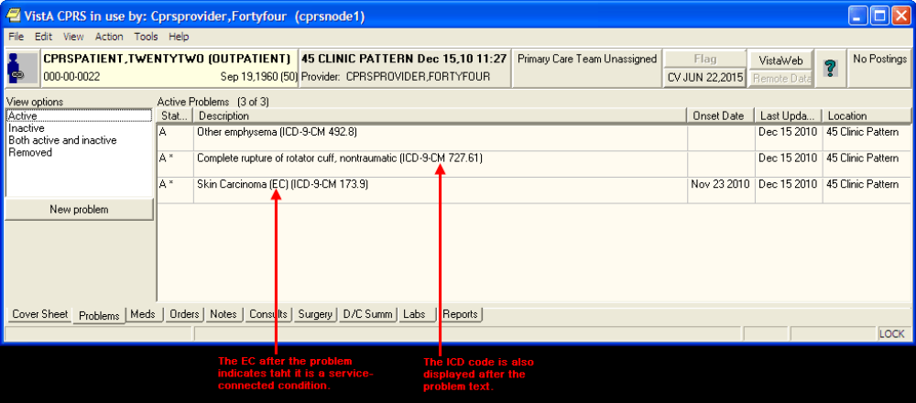
PLPROVIDER,TWO
PLPROVIDER,TWO
PLPROVIDER,TWO
PLPROVIDER,TWO
PLPROVIDER,TWO
PLPROVIDER,TWO

View Options
You have a choice of how to display a patient’s problems: active problems only, inactive problems only, both active and inactive problems, and problems for a selected service or provider by customizing your view of the problem list.

You can change the view, add, deactivate, remove, verify, or annotate problems.
When “Removed” problems are viewed, the “Stat/Ver” column is hidden to minimize user confusion about the status of “Removed” problems.

Changing Views on the Problem List

Changing the view of the Problem List allows you to focus the list of problems on one of several criteria. Focusing the list will speed up the selection process.
Problems List views:
- Active
- Inactive
- Active and Inactive
- Removed
To change the view, click on any of the options listed in the View options field or click on View on the menu.
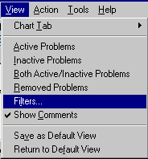

Filters
Select the Filters option on the menu to further focus the list of problems you wish to have displayed. From the Filters dialog, you may choose to display problems by any combination of Status, Source Clinic (which is listed when you select Outpatient), Source Service (which is listed when you select Inpatient), and Provider.
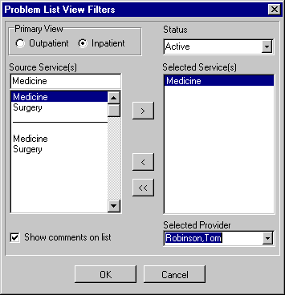
PLPROVIDER,ONE

Package Operation

Package Operation

How to Use Problem List

Operation of Problem List will vary from site to site, depending on the data entry method your hospital has chosen. Typical scenarios that might be used are described on the next two pages.

The actions for both clinician entry and clerk entry are essentially identical. In the descriptions on the following pages, differences between the two are noted.

The basic operation of the Problem List program is very simple:

1. Pick a patient.

2. Enter the Provider Name, if you’re a clerk.

3. The patient’s problem list is displayed.

4. Perform one of several possible actions, such as add a new problem, edit a problem, print a problem list, as described on the following pages.

Potential Scenarios for Problem List Entry

Outpatient Scenarios

A. Direct data entry into the Problem List: A clinician (nurse, Physician Assistant, physician) compiles a list of patient problems relevant to the visit by direct data entry into either the CPRS GUI, the CPRS List Manager, or the Problem List package.

B. Manual entry into encounter form: A patient checks in, is seen by a clinician, and an encounter form (usually an electronically generated form from the Integrated Billing software) is filled out by the provider. Problems addressed in the visit are captured. A purpose of visit may be recorded. The encounter form may be generic or it may be patient-specific, with ID, demographics, and Service Connection (SC) information. It may be customized to the clinic as well, with clinic, provider, and clinic-specific procedures and diagnoses. Data entry is done by a provider, who may check items or fill in free text. The provider must note which services delivered were for a service-connected condition. The provider may, in some cases, use the same form to create a progress note.

A clerk transcribes the problem and procedure data from the form into VistA. Free-text problem entries will be transferred to the computer to the best of the clerk’s ability. Unclear entries will be returned to the provider for clarification. A new encounter form is electronically generated from this data, to be used by the provider the next time he/she enters data for the patient.

C. Same as above, except that after the encounter form is completed by the provider, it is scanned (through a scanning device), and entered electronically into DHCP.

Inpatient Scenarios

A. A clinician (nurse, Physician Assistant, physician) compiles the list of patient problems relevant to the hospitalization. Presently, this is mainly done by direct data entry. The potential applications of Problem List data during inpatient stays include Treatment Plans, creation of headers for Progress Notes, preparation of a prompt sheet for a discharge document, and worksheets for rounds. Problem data may benefit the Utilization Review specialist who must submit data for certification of ongoing inpatient treatment.

Another scenario would be using the application to create a problem list (VAF 10-1415) when one is required, as for a new patient with a new chart.

B. A clerk transcribes patient information entered by a provider on an encounter form designed to capture problem data for an inpatient. The clerk enters data from checkbox entries and free-text entries. The clerk then prints a turnaround form to allow the provider to correct errors. Clerks will record corrections and set a verification flag. (Providers may verify data online, as well.)

Problem List in CPRS GUI

Problem List is available as a tab on the CPRS GUI Cover Sheet. The Cover Sheet is the first screen you see after opening a patient record unless your site defines another tab as the initial tab. It presents a quick overview of a patient’s condition and history. It shows active problems, allergies and postings, active medications, clinical reminders, lab results, vitals, and a list of appointments or visits.

See Appendix A for information about using the new Lexicon Search capability and using NTRT to add new problem terms.

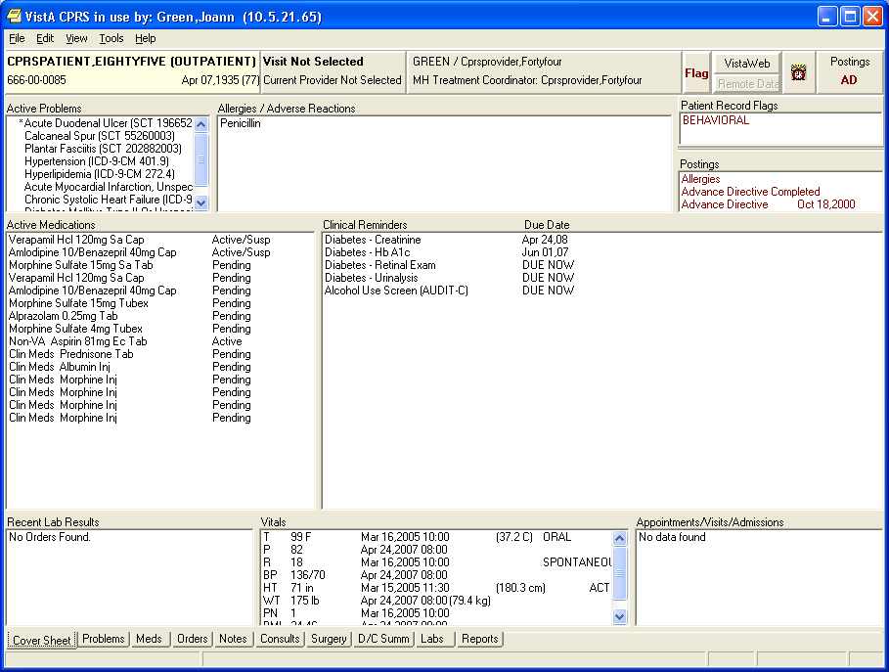

You can quickly review the active problems (asterisks identify acute problems, and dollar signs identify unverified problems).

Scroll bars beside a box mean that more information is available if you scroll up or down.

Single-click on one of the five menus: File, Edit, View, Tools, or Help, to see choices of things you can do or other options available to you.

File Menu
The File menu contains three commands that you will use often:
- Select New Patient brings up the Patient Selection dialog.
- Update/Provider/Location brings up a dialog that enables you to change the clinician or location of an encounter.
- Review/Sign Changes enables you to view the orders you have placed that require an electronic signature, select the orders you want to sign at this time, and enter your electronic signature (if you are authorized to sign them).
Click on any Problem List item on the cover sheet to get more detailed information.

Example
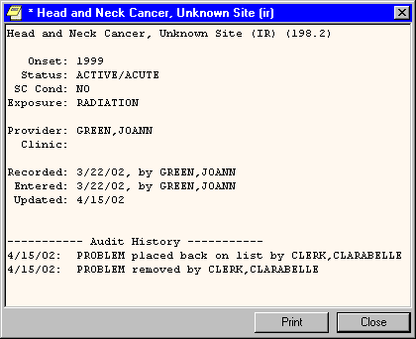
PLPROVIDER,ONE
PLPROVIDER,ONE
PLPROVIDER,ONE
PLCLERK,ONE
PLCLERK,ONE

Problems Tab
When you click on the Problems Tab, a screen similar to the following opens up:

PLPROVIDER,TWO
PLPROVIDER,TWO
PLPROVIDER,TWO
PLPROVIDER,TWO
PLPROVIDER,TWO
PLPROVIDER,TWO

View Options
You have a choice of how to display a patient’s problems: active problems only, inactive problems only, both active and inactive problems, and problems for a selected service or provider, by customizing your view of the problem list.

You can change the view, add, deactivate, remove, verify, or annotate problems.
When “Removed” problems are viewed, the “Stat/Ver” column is hidden to minimize user confusion about the status of “Removed” problems.
Adding a Problem

You add a new problem from the Problems tab. From this tab, you can add, remove, change, verify, and annotate a problem.

See Appendix A for information about using the new Lexicon Search capability and using NTRT to add new problem terms.

Steps to add a new problem to a patient’s problem list:
- Click the Problems tab.
- Click New Problem. The Problem List Lexicon Search box appears.

Note: | If you have not defined the provider or location, you will be prompted for this encounter information.

: 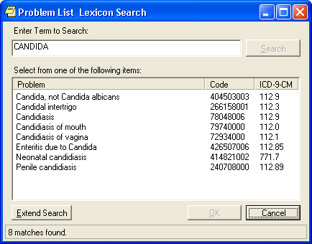
- Select a problem from the list or search the lexicon for the problem by clicking Extend Search on the lower left side of the Problems tab, entering terms that describe the problem in the Problem List Lexicon Search field, and then pressing Enter or click Search. When the list appears, locate and click on the problem.
- Enter information about the problem, such as whether it is acute or chronic, treatment factors (Service Connected, Radiation, Agent Orange, or Environmental Contaminants), the Date of Onset, the provider, and the clinic.
- Add a comment if you wish by clicking Add Comment and entering the comment in the dialog that appears. Then click OK.
- Click OK again.
- If you select Extend Search, a screen such as the following appears. You can select one of the listed terms or click on the Freetext Problem button.
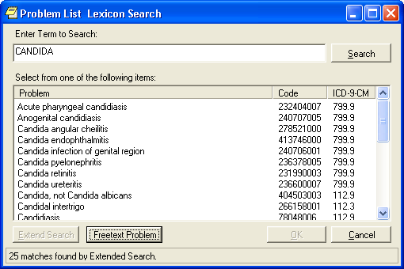
If you click on the Freetext Problem button, you have a choice of Requesting a New Term.
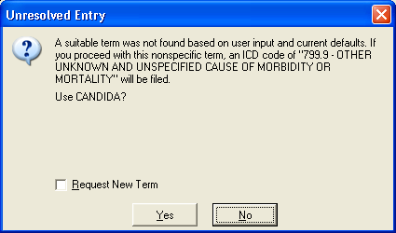

Note: | See Appendix A for more details about requesting new terms.

Annotating a Problem

To annotate a problem, use these steps:
1. Click on the problem in the problem list.
2. Select Action | Annotate... or right-click the problem and select Annotate... from the pop-up menu.
3. Enter your annotation in the dialog that appears (up to 60 characters).
4. Click OK.

Changing a Problem

To change a problem on a patient’s problem list, use these steps:
1. Click the Problems tab.
2. Click on the problem in the list box that you want to change.
3. Select Action | Change.
4. Enter the desired changes.
5. Add or remove a comment if desired.
Note: A comment can be as many as 60 characters (including spaces) in length.
6. Click OK.

Note: | When you view the details of a problem, you will see who changed the problem and when.

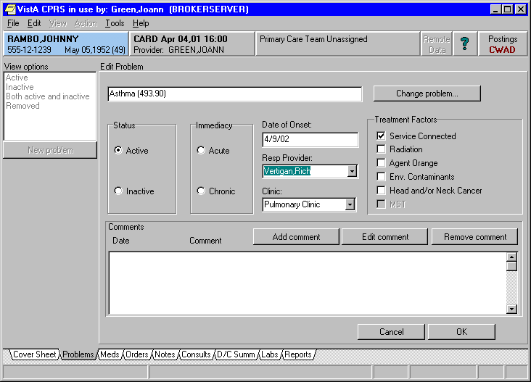

PLPATIENT,ONE
666-00-1111 APR 30,1044 (56)

PLPROVIDER,ONE
PLPROVIDER,ONE

Deactivating a Problem

To deactivate a problem on a patient’s problem list, use the following steps:
1. Click on a problem in the list box.
2. Select Action | Inactivate.

Removing a Problem

A problem is not removed from the database because things “pointing” to it might be broken if it is removed. A field in the problem record can be “flagged” with an “H” and the problem will be HIDDEN. Any software that runs on the database must look at the field to see if it is hidden or not. The hidden record will not appear on any reports or lists and will appear to the user that it has been removed. Actually it is only removed from sight.
To remove a problem from a patient’s problem list, use these steps:
1. Click on the problem.
2. Select Action | Remove or right-click the problem and click Remove.

Verifying a Problem

To verify a problem on a patient’s problem list, use these steps:
1. Click on the problem in the problem list.
2. Select Action | Verify or right-click the problem and click Verify on the pop up menu.

Customizing the Problem List

On the Problems tab, you can sort the problem list by problem status or use the view filtering to get a more specific list of problems. You can sort the list to see the following:

- Active Problems
- Inactive Problems
- Both Active/Inactive Problems
- Removed Problems

Problem List in CPRS List Manager

Using Problem List through the List Manager version of CPRS is very similar to using it directly in the Problem List application. The advantage of using it in CPRS is that you also have access to the complete patient chart, which includes Orders, Notes, Reports, Summaries, and Meds.

When you sign in to the List Manager version of CPRS, the first screen you see is the Patient Selection screen. If you have a default list defined, the names on the list will appear here for you to select from.

Steps to use Options:

1. Select patient name.

Patient Selection Apr 12, 2002@11:37:30 Page: 1 of 1
Current patient: ** No patient selected **

Patient Name ID DOB Room-Bed
No patients found

Enter the number of the patient chart to be opened >>>
+ Next Screen CV Change View ... FD Find Patient
- Previous Screen SV (Save as Default List)Q Close

Select Patient: Change View//CPRSPATIENT,EIGHT *SENSITIVE
* *SENSITIVE* YES SC VETERAN C

***WARNING***
***RESTRICTED RECORD***
* * * * * * * * * * * * * * * * * * * * * * * * * * * * * * * * * * * * *
* This record is protected by the Privacy Act of 1974. If you elect *
* to proceed, you will be required to prove you have a need to know. *
* Accessing this patient is tracked, and your station Security Officer *
* will contact you for your justification. *
* * * * * * * * * * * * * * * * * * * * * * * * * * * * * * * * * * * * *

Do you want to continue processing this patient record? No// Y (Yes)

Searching the patient's chart ...

NW Enter New Allergy/ADR CV (Change View ...) SP Select New Patient
AD Add New Orders CC Chart Contents ... Q Close Patient Chart

Select: Next Screen// CC Chart Contents ...
2. Select CC, Chart Contents, to see the “tabs” or components of the patient chart.

Cover Sheet Jun 29, 2012@10:10:28 Page: 1 of 2
CPRSPATIENT,EIGHT 666-06-1008 ICU/CCU 4/15/53(59)
Attend: CPRSPROVIDER,O PrimCare: CPRSPROV,F PCTeam: GREEN

Item Entered
Allergies/Adverse Reactions |
No assessment available |
|
Patient Postings |
<None> |
|
Recent Vitals |
No data available |
|
Recent Immunizations |
|
Eligibility |
Not Service Connected |
+ Enter the numbers of the items you wish to act on.
Cover Sheet Orders Imaging Reports
Problems Meds Consults
Notes Labs D/C Summaries
Select chart component: P Problems
Searching the patient's chart ...

3. Select Problems for the Problem List.

Active Problems Jun 29, 2012@10:10:42 Page: 1 of 2
CPRSPATIENT,EIGHT 666-06-1008 ICU/CCU 4/15/53(59)
Attend: CPRSPROVIDER,O PrimCare: CPRSPROV,F PCTeam: GREEN

Problem Onset Updated Status
1 Abdominal pain (SCT 21522001) | 04/23/08 active
2 Abdominal pain (SCT 21522001) | 04/23/08 active
testing problem update from encounter |
form - same session as |
3 Acute conjunctivitis (SCT 53726008) | 04/23/08 active
4 Anger reaction (SCT 192085004) | 04/23/08 active
5 Winter itch (SCT 201025002) | 04/23/08 active
6 Smith-Lemli-Opitz syndrome (SCT | 04/23/08 active
43929004) |
7 Edema (SCT 267038008) | 04/23/08 active
8 Hypertensive disorder (SCT 38341003) | 00/00/94 04/18/08 active
entered on problems tab. |
9 Gastresophageal reflux disease (SCT | 04/18/08 active
+ Enter the numbers of the items you wish to act on.
Select: Next Screen// 1
Inactivate Add Comment Detailed Display
Remove Edit Verify
Select Action: E Edit
Patient Location: Mental Health
Retrieving current data for problem

PROBLEM LIST Jun 29, 2012@10:28:15 Page: 1 of 1
CPRSPATIENT,EIGHT (C1008) Last Updated: Apr 23, 2008

1 Problem: Abdominal pain

2 Onset: unknown 6 SC Condition: unknown
3 Status: ACTIVE 7 Exposure: <None>
4 Provider: CPRSPROVIDER,ONE
5 Service:

Comments:

Enter the number of the item(s) you wish to change
CM Additional Comments RM Remove Problem from List
Q Quit w/o Saving Changes SC Save Changes and Exit

Select Item(s): Quit// 5 5
SERVICE: MEDICINE

PROBLEM LIST Jun 29, 2012@10:38:16 Page: 1 of 1
CPRSPATIENT,EIGHT (C1008) Last Updated: Apr 23, 2008

1 Problem: Abdominal pain

2 Onset: unknown 6 SC Condition: unknown
3 Status: ACTIVE 7 Exposure: <None>
4 Provider: CPRSPROVIDER,ONE
5 Service: MEDICINE

Comments:

Enter the number of the item(s) you wish to change
CM Additional Comments RM Remove Problem from List
Q Quit w/o Saving Changes SC Save Changes and Exit

Select Item(s): Save Changes and Exit// <Enter>
Save Changes and Exit

Saving ... done.

Potential Scenarios for Problem List Entry

Outpatient Scenarios

A. Direct data entry into the Problem List: A clinician (nurse, Physician Assistant, physician) compiles a list of patient problems relevant to the visit by direct data entry into either the CPRS GUI, the CPRS List Manager, or the Problem List package.

B. Manual entry into encounter form: A patient checks in, is seen by a clinician, and an encounter form (usually an electronically generated form from the Integrated Billing software) is filled out by the provider. Problems addressed in the visit are captured. A purpose of visit may be recorded. The encounter form may be generic or it may be patient-specific, with ID, demographics, and Service Connection (SC) information. It may be customized to the clinic as well, with clinic, provider, and clinic-specific procedures and diagnoses. Data entry is done by a provider, who may check items or fill in free text. The provider must note which services delivered were for a service-connected condition. The provider may, in some cases, use the same form to create a progress note.

A clerk transcribes the problem and procedure data from the form into VistA. Free-text problem entries will be transferred to the computer to the best of the clerk’s ability. Unclear entries will be returned to the provider for clarification. A new encounter form is electronically generated from this data, to be used by the provider the next time he/she enters data for the patient.

C. Same as above, except that after the encounter form is completed by the provider, it is scanned (through a scanning device), and entered electronically into DHCP.

Inpatient Scenarios

A. A clinician (nurse, Physician Assistant, physician) compiles the list of patient problems relevant to the hospitalization. Presently, this is mainly done by direct data entry. The potential applications of Problem List data during inpatient stays include Treatment Plans, creation of headers for Progress Notes, preparation of a prompt sheet for a discharge document, and worksheets for rounds. Problem data may benefit the Utilization Review specialist who must submit data for certification of ongoing inpatient treatment.

Another scenario would be using the application to create a problem list (VAF 10-1415) when one is required, as for a new patient with a new chart.

B. A clerk transcribes patient information entered by a provider on an encounter form designed to capture problem data for an inpatient. The clerk enters data from checkbox entries and free-text entries. The clerk then prints a turnaround form to allow the provider to correct errors. Clerks will record corrections and set a verification flag. (Providers may verify data online, as well.)

Using Problem List through the Problem List Program in List Manager

Patient Problem List Option [GMPL CLINICAL USER]

This option lets clinicians use the Problem List program to review a patient’s problems, add a new problem, edit an existing problem, inactivate a problem, and a number of other actions, as described in the following pages.

Note: | Problems on the list will appear in chronological order unless you choose reverse chronological order in the Edit PL Site Parameters option (on the Problem List Mgt Menu).

Select Option: Patient Problem List
Select PATIENT NAME: PLPATIENT,ONE 03-04-14 666001111 SC VETERAN
Searching for the patient's problem list...

1. Select the Patient Problem List option from your clinical menu. (Each site will decide what menu to place this option on.)

2. Type the name of the patient whose problem you wish to enter.

The patient’s problem list is then displayed, as shown in the example below:

PROBLEM LIST Jun 29, 2012@09:11:27 Page: 1 of 2
CPRSPATIENT,FIFTEEN (C0010) 6 active problems
ACTIVE PROBLEMS
Problem Updated Clinic
1 frac (ICD-9-CM 799.9) 6/1/12 45 PATTERN
2 Hypertension (ICD-9-CM 401.9), Onset 4/10/07
4/7/05
3 Hyperlipidemia (ICD-9-CM 272.4), Onset 4/10/07
4/7/05
4 Acute myocardial infarction, unspecified 3/17/05 GENERAL MEDICINE
site, episode of care unspecified
(ICD-9-CM 410.90), Onset 3/17/05
5 Chronic Systolic Heart failure (ICD-9-CM 3/9/04 GENERAL MEDICINE
428.22), Onset 3/9/04
+ + Next Screen - Prev Screen ?? More actions
AD Add New Problems IN Inactivate Problems VW Select View of List
RM Remove Problems CM Comment on a Problem SP Select New Patient
ED Edit a Problem DT Detailed Display PP Print Problem List
Q Quit
Select Action: Next Screen//

REMEMBER: You can respond to many prompts by typing the first few letters of a name, option, or action. Some option names have “mnemonics” — an abbreviation that you can enter rather than the entire option name.

Problem List Data Entry [GMPL DATA ENTRY]

This option lets clerks enter and maintain Problem Lists. Clerks can enter new problems, edit problems, remove, or print a problem. The clerks in outpatient clinics will probably be working with Encounter Forms (or similar data entry forms) to enter and edit problems that clinicians have entered onto the forms.

Note: | When problems are entered into the problem list with no ICD code attached, the system automatically assigns the number 799.9. This number can be replaced by the correct number through the option Assign ICD Diagnoses to Problem List, described on the next page.

Select Option: Problem List Data Entry
Select PATIENT NAME: CPRSPATIENT,EIGHT 06-18-62 666221008
Searching for the patient's active problem list...

1. Select the Problem List Data Entry option from your clinical menu. (Each site will decide what menu to place this option on.)

2. Type the name of the patient whose problem you wish to enter.

3. Type the name of the Provider for this problem list.

PROBLEM LIST Jun 29, 2012@09:37:10 Page: 1 of 3
CPRSPATIENT,EIGHT (C1008) 14 active problems
ACTIVE PROBLEMS
Problem Updated Clinic
1 Abdominal pain (SCT 21522001) 4/23/08 20 MINUTE
2 Abdominal pain (SCT 21522001) 4/23/08 20 MINUTE
3 Acute conjunctivitis (SCT 53726008) 4/23/08 20 MINUTE
4 Anger reaction (SCT 192085004) 4/23/08 20 MINUTE
5 Winter itch (SCT 201025002) 4/23/08 20 MINUTE
6 Smith-Lemli-Opitz syndrome (SCT 4/23/08 20 MINUTE
43929004)
7 Edema (SCT 267038008) 4/23/08 20 MINUTE
8 Hypertensive disorder (SCT 38341003), 4/18/08 20 MINUTE
+ + Next Screen - Prev Screen ?? More actions
AD Add New Problems IN Inactivate Problems VW Select View of List
RM Remove Problems CM Comment on a Problem SP Select New Patient
ED Edit a Problem DT Detailed Display PP Print Problem List
$ Verify Problems Q Quit
Select Action: Next Screen//

4. Select the Action you wish to take (add, remove, edit, etc.).

Assign ICD Diagnoses to Problem List [GMPL CODE LIST]

This option lets you:

- Add, review, or edit the ICD Code assigned to each problem

- See a detailed display of problem data

- Search both the ICD Diagnosis file and the Lexicon Utility to find appropriate codes to assign

Note: | When problems are entered into the problem list with no ICD code attached, the system automatically assigns the number 799.9. This number can be replaced by the correct number through the option Assign ICD Diagnoses to Problem List, described on the next page.

Select Option: pl Assign ICD Diagnoses to Problem List
Select PATIENT NAME: CPRSPATIENT,EIGHT 03-04-14 666431008 SC VETERAN
Searching for the patient's problem list...

1. Select Assign ICD Diagnoses to Problem List from your clinical menu. (Each site will decide what menu to place this option on.)

2. Type the name of the patient whose problem you wish to code.

The patient’s problem list is then displayed, as shown in the example below:

PROBLEM LIST Jun 29, 2012@13:33:05 Page: 1 of 2
CPRSPATIENT,EIGHT (C1008) 14 problems
ALL PROBLEMS
Problem ICD SC Exposure Resolved
1 Abdominal pain (SCT 21522001) 789.00
2 Abdominal pain (SCT 21522001) 789.00
3 Acute conjunctivitis (SCT 53726008) 372.00
4 Anger reaction (SCT 192085004) 312.00
5 Winter itch (SCT 201025002) 698.8
6 Smith-Lemli-Opitz syndrome (SCT 759.89
43929004)
7 Edema (SCT 267038008) 782.3
8 Hypertensive disorder (SCT 38341003), 401.9 NO
Onset 1994
+ + Next Screen - Prev Screen ?? More actions
DT Detailed Display SP Select New Patient
CD Search ICD Diagnoses for Codes Q Quit

Select Action: Next Screen//

Select Action: Next Screen// CD Search ICD Diagnoses for Codes
Select Problem(s) (1-32): 1

Problem #1: Motion Sickness
Enter ICD CODE or DESCRIPTION: 904.6

3. Type CD for Search ICD Diagnoses for Codes.

4. Type the number of the problem to add a code for (or to edit or review).

5. Type in the new code number or a brief description of the problem. If you don’t know the ICD code for this problem, the Lexicon Utility look-up will search the records to find a code that matches the problem.

How to Use Problem List User List Manager Actions

The Patient Problem List and Problem List Data Entry options in List Manager present screens that contain patient information and one or more problems for that patient (if they have been previously entered). At the bottom of this screen are a number of actions you can perform at this time. This section describes the following user actions:

Add New Problems
Comment on a Problem
Detailed Display
Edit a Problem
Inactivate Problems
Print Problem List
Remove Problems
Select New Patient
Select View of List
Show All Problems
Verify Problems
More Actions

Note: | Other actions are available on management screens, but they aren’t described individually in this manual. See the Package Management section earlier in this manual for further information about management actions.

ACTIONS

Add New Problems

Follow the steps listed below the sample screen on the right to create a problem list for a patient or add a new problem to an already existing problem list.

Note: | New problems that you add will appear at the bottom of the list unless you change the display to reverse chronological order through the option Edit PL Site Parameters. They will then appear at the top of the list.

Note: | If there is more than one match to the problem you enter, a list is displayed for you to select from.

These lists are displayed in groups of five. If there are more than five matches and you want to scroll back to a previous batch of five, type ^(#) – e.g., ^1 – and the screen will re-display the first group.
Example 1
Select PATIENT NAME: PLPATIENT,ONE 03-04-14 666001111 NSC VETERAN

Searching for the patient's problem list...

PROBLEM LIST Apr 30, 2004 15:40:06 Page:1 of 3
PLPATIENT,ONE (P1111) 12 active problems
ACTIVE CLINIC PROBLEMS
Problem Updated Clinic
1 Generalized aches, pain or 4/29/04 ISC
stiffness, Onset 4/25/04
Associated with nausea.
2 Dream anxiety disorder (Nightmare 4/26/04 PSYC
disorder), Onset 11/27/92
Lives on Elm Street.
3 Arm Pain, Onset 3/30/04 4/7/04 AC
4 Nocturnal Leg Cramps, Onset 3/30/04 4/1/04 AC
Can’t sleep.
5 Constipation, Onset 3/10/93 4/1/04 AC
+ + Next Screen - Prev Screen ?? More actions
AD Add New Problems IN Inactivate Problems VW Select View of List
RM Remove Problems CM Comment on a Problem SP Select New Patient
ED Edit a Problem DT Detailed Display PP Print Problem List
$ Verify Problems Q Quit

Select Action: Next Screen// AD Add New Problem
Clinic: Podiatry
PROBLEM: Diabetes Mellitus
Searching....
The following 10 matches were found
1. Diabetes Mellitus * (ICD 250.0) (SNM D-2381)
2. Diabetes mellitus without mention of complication (ICD 250.0)
3. Diabetes Mellitus, Experimental *
4. Diabetes Mellitus, Insulin-Dependent * (ICD 256.01) (SNM D-2385/D-241X)
5. Diabetes Mellitus, Lipoatrophic * (SNM D-2402)
Select 1-5, ‘^(number)’ to jump, ‘^’ or (enter): 1

1. Type the name of the patient to add a problem for.

2. Type AD at the “Select Action” prompt.

3. If the patient is an outpatient, you will be prompted for a clinic.

4. Enter the name of the problem you wish to add to the patient’s problem list. You will be re-prompted for “PROBLEM” until you press return.

The patient’s problem should be entered in clinical terms. You can use one full word or two to three partial words; for example, DIABETES, DIAB MELL, or DIAB MELL INSUL.

- You can enter as many comments to a problem (up to 60 characters each) as you wish.
- The date of onset should be the date the problem was first observed, as precisely as known.
- If you have no idea of the date, press return to bypass the prompt.

Example 1 (cont’d)

COMMENT (<60 char): Check foot sore
DATE OF ONSET: T-3 (MAY 19, 2004)
STATUS: ACTIVE// <Enter>
(A)cute or (C)hronic: Chronic

>>> Currently known service-connection data for CUMQUAT,EARNEST.:
SC %: 50%
Disabilities: NONE STATED
Is this problem related to a service-connected condition? Y YES
Is this problem related to AGENT ORANGE EXPOSURE? N NO
Is this problem related to RADIATION EXPOSURE? Y

Problem: Diabetes Mellitus
<1 comment appended>
Onset: 5/17/04 SC Condition: YES
Status: ACTIVE/CHRONIC Exposure: RADIATION
Provider: PLPROVIDER,ONE
Clinic : Podiatry
Recorded : 5/22/04 by PLPROVIDER,ONE

(S)ave this data, (E)dit it, or (Q)uit w/o saving? SAVE// <Enter>
Saving......done

Please enter another problem, or press <return> to exit. <Enter>

(Problem List screen is re-displayed)

5. Enter a comment (less than 60 characters), the date of onset, status of problem (active or inactive, acute or chronic), and service-connection. All responses are optional. If you don’t respond to Status, it will default to Active.

6. Add more problems or edit problems, if you wish.

7. When you exit this patient’s list, you are prompted to print a new problem list. Press return if you want a new list printed. Otherwise, type No. See the Print Problem List action description in this manual for examples of printed problem lists.

Note: | You must already have a selection list created for this example.

This example illustrates use of a General Medicine List to choose problems from.
(See the Package Management section for descriptions of creating customized selection lists or customizing your view of problems.)

Example 2: Adding a problem from a selection list.
Select PATIENT NAME: PLPATIENT,ONE 03-04-14 666001111 NSC VETERAN

Searching for the patient's problem list...

PROBLEM LIST Apr 30, 2004 15:40:06 Page:1 of 3
PLPATIENT,ONE (P1111) 12 active problems
ACTIVE PROBLEMS
Problem Updated Clinic
1 Generalized aches, pain or 4/29/04 ISC
stiffness, Onset 4/25/04
Associated with nausea.
2 Dream anxiety disorder (Nightmare 4/26/04 PSYC
disorder), Onset 11/27/92
Lives on Elm Street.
3 Arm Pain, Onset 3/30/04 4/7/04 AC
4 Nocturnal Leg Cramps, Onset 3/30/04 4/1/04 AC
Can’t sleep.
5 Diabetes Mellitus, 4/27/04
+ + Next Screen - Prev Screen ?? More actions
AD Add New Problems IN Inactivate Problems VW Select View of List
RM Remove Problems CM Comment on a Problem SP Select New Patient
ED Edit a Problem DT Detailed Display PP Print Problem List
$ Verify Problems Q Quit

Select Action: Next Screen// AD Add New Problems
Clinic: General Medicine
.

1. Type the name of the patient whose problem you wish to add.

2. Type AD at the “Select Action” prompt.

3. Type the name of the clinic you have a selection list defined for.

Cont’d on next page...

Add New Problems, cont’d

- You can enter as many comments to a problem (up to 60 characters each) as you wish.
- The date of onset should be the date the problem was first observed, as precisely as known. If you have no idea, press return to bypass the prompt.
- All responses are optional. If you don’t respond to Status, it will default to Active.

Example 2 (cont’d) Using a pre-defined selection list
PROBLEM LIST FEB 30, 2004 15:40:06 Page:1 of 3
PLPATIENT,ONE (P1111) 12 active problems
AMBULATORY CARE

1 Endocrine & Metabolic ...

2 Iron deficiency anemia (280.8)
3 Macrocytic Anemia (281.91)
4 Other Anemia (285.9)
5 Diabetes Mellitus (250.00)

Enter the number of the item(s) you wish to view

AD Add a Problem not on a menu Q Quit to Problem List

Select Item: Next Screen// 2

>>> Adding Problem #2 ‘Iron deficiency anemia’...
COMMENT (<60 char): Seems pretty rundown
ANOTHER COMMENT: <Enter>
DATE OF ONSET: T-30 (January 30,2004)
STATUS: ACTIVE// <Enter>
(A)cute or (C)hronic: ??
You may further refine the status of this problem by designating it as ACUTE or CHRONIC; problems marked as ACUTE will be flagged on the list display with a '*'.

(A)cute or (C)hronic: A
>>> Currently known service-connection data for PLPATIENT,ONE:
SC %: 50%
Disabilities: NONE STATED
Is this problem related to a service-connected condition? Y YES
Is this problem related to AGENT ORANGE EXPOSURE? N NO
Is this problem related to RADIATION EXPOSURE? Y

Problem: Iron deficiency anemia
<1 Comment appended>
Onset: January 2004 SC Condition: YES
Status: ACTIVE/ACUTE Exposure: RADIATION
Provider: PLPROVIDER,ONE
Clinic: GENERAL MEDICINE
Recorded: 2/10 by PLPROVIDER,ONE

(S)ave this data, (E)dit it, or (Q)uit w/o saving? SAVE// <Enter>

4. Select a problem from the list that is displayed or add a problem not on the list.

5. Enter a comment (less than 60 characters), the date of onset, status of problem (active or inactive), and service-connection.

Add New Problems, cont’d

- If you have a pre-defined selection list, but the problem you wish to add isn’t on that list, you may choose a problem from the Lexicon Utility.

- If an asterisk is by the term, you can type in ?(#) and get a brief description of the term.

- The date of onset should be the date the problem was first observed, but you can bypass the prompt if unknown.
- All responses are optional. If you don’t respond to Status, it will default to Active.

Example 3: Adding a problem not on a menu, when you have a selection list defined
PROBLEM LIST Feb 30, 2004 15:40:06 Page:1 of 3
PLPATIENT,ONE (P1111) 12 active problems
GENERAL MEDICINE
1 ENDOCRINE & METABOLIC
2 HEMATOLOGIC
3 LYMPHATIC
4 MUSCULOSKELETAL

Enter the number of the item(s) you wish to view
AD Add a Problem not on a menu Q Quit to Problem List

Select Category: Quit to Problem List// AD
Add Problem not on a menu
>>> Adding a problem not on the menu ...
PROBLEM: Anemia

The following 55 matches were found:
1: Anemia *
2: Anemia NEC
3: Anemia of chronic disease
4: Anemia, Aplastic *
5: Anemia, Cooley's
Select 1-5, ‘#(number)’ to jump, ‘^’ or (enter): 1
COMMENT (<60 char): Aggravated by flu
ANOTHER COMMENT: <Enter>
DATE OF ONSET: T-3 (FEB 07, 2004)
STATUS: ACTIVE// <Enter>
(A)cute or (C)hronic: ACUTE

>>> Currently known service-connection data for CUMQUAT,EARNEST.:

SC Percent: 50%
Disabilities: NONE STATED

Is this problem related to a service-connected condition? Y YES
Is this problem related to AGENT ORANGE EXPOSURE? N NO
Is this problem related to RADIATION EXPOSURE? Y
Problem: Anemia
<1 Comment appended>
Onset: 2/07/04 SC Condition: YES
Status: ACTIVE/ACUTE Exposure: RADIATION
Provider: PLPROVIDER,ONE
Clinic: GENERAL MEDICINE
Recorded: 2/10 by PLCLERK,ONE

(S)ave this data, (E)dit it, or (Q)uit w/o saving? SAVE// <Enter>

1. Select AD for Add a Problem not on the menu.

2. Type the name of the problem.

3. Enter a comment(s) (less than 60 characters), the date of onset, status of problem (active or inactive), and service-connection.

Add New Problems – Clerk Entry

Clerks can enter new problems to a patient’s problem list, from an encounter form or other types of documentation.

Example 4: Clerk Entry
Select PATIENT NAME:PLPATIENT,ONE 03-04-14 666001111 NSC VETERAN
Provider: PLPROVIDER,ONE

Searching for the patient's problem list...

PROBLEM LIST Apr 16, 2004 14:19:45 Page: 1 of 2
PLPATIENT,ONE (P1111) 8 of 26 active problems
ACTIVE PROBLEMS
Problem ICD SC Exposure Resolved
1 Multiple Sclerosis 340 YES Agent Orange
2 Cholecystitis YES Radiation
3 Diabetes Mellitus NO
4 Hemotysis NO
5 Rib Fractures NO
6 Pneumonia, Pneumocystis carinii
7 Respiratory Distress Syndrome, Adult
8 Peripheral Vascular Disease Leg/Foot

+ + Next Screen - Prev Screen ?? More actions
AD Add New Problems IN Inactivate Problems SP Select New Patient
RM Remove Problems CM Comment on a Problem PP Print Problem List
ED Edit a Problem VW Show All Problems Q Quit

Select Action: Next Screen// AD
Clinic: Cardiology
PROBLEM: Anemia

1. Type the name of the patient whose problem you wish to add.

2. Enter the name of the provider.

3. Type AD at the “Select Action” prompt.

4. Enter the name of the clinic the patient is in, if known.

5. Enter the name of the patient’s problem.

Add New Problems
Clerk Entry (cont’d)

You may further refine the status of this problem by designating it as acute or chronic; problems marked as acute will be flagged on the list display with an asterisk.

COMMENT (<60 char): Aggravated by flu
DATE OF ONSET: T-30 (JAN 19, 2004)
STATUS: ACTIVE// <Enter>
(A)cute or (C)hronic: ACUTE
>>>Currently known service-connection data for ADAMS,HOUSTON.:
SC Percent:
Disabilities: NONE STATED

Is this problem related to a service-connected condition? No
Is this problem related to Agent Orange exposure? No
Is this problem related to RADIATION exposure? No
Is this problem related to ENVIRONMENTAL CONTAMINANTS exposure? No
------------------------------------------------------------------
Problem: ANEMIA

Onset: Nov 30, 2004 SC Condition: NO
Status: ACTIVE/ACUTE Exposure: NONE
Provider: PLPROVIDER,ONE
Clinic: CARDIOLOGY
Recorded: 2/10 by PLCLERK,ONE

-------------------------------------------------------------------
(S)ave this data, (E)dit it, or (Q)uit w/o saving? SAVE// <Enter>
Saving ...DONE

>>> Please enter another problem, or press <return> to exit.
PROBLEM: <Enter>

7. Enter comments, date of onset, the status of the problem (active or inactive, acute or chronic), and service-connection information (if any).

All of these responses are optional. If you don’t respond to Status, it will default to Active.

Comment on a Problem

You can add a note or comments to your own or another clinician’s patient problem. Clerks can also enter comments provided to them by clinicians.

Note: | 1-12 problems are indicated, while only 5 problems are displayed above. The + means there are more problems. Type in + at the “Select Action” prompt o see the remainder.

You can enter up to 60 characters. Only your own notes will appear on the problem list display. Others can be seen if you select DT for Detailed Display.

Select PATIENT NAME: PLPATIENT,ONE 03-04-14 666001111 NSC VETERAN
Searching for the patient's problem list...

PROBLEM LIST Apr 30, 2004 15:40:06 Page:1 of 3
PLPATIENT,ONE (P1111) 12 active problems
ACTIVE PROBLEMS
Problem Updated Clinic
1 Generalized aches, pain or 4/29/04 ISC
stiffness, Onset 4/25/04
Associated with nausea.
2 Dream anxiety disorder (Nightmare 4/26/04 PSYC
disorder), Onset 11/27/92
Lives on Elm Street.
3 Arm Pain, Onset 3/30/04 4/7/04 AC
4 Nocturnal Leg Cramps, Onset 3/30/04 4/1/04 AC
5 Diabetes Mellitus, 4/27/04

+ + Next Screen - Prev Screen ?? More actions
AD Add New Problems IN Inactivate Problems VW Select View of List
RM Remove Problems CM Comment on a Problem SP Select New Patient
ED Edit a Problem DT Detailed Display PP Print Problem List
$ Verify Problems Q Quit
Select Action: Next Screen// cm Comment on a Problem
Select Problem (1-12): 4
Nocturnal Leg Cramps
COMMENT (<60 char): Low RBC mass
Another Comment: <Enter>

1. Type the patient’s name.

2. Type CM for Comment on a Problem.

3. Type the number of the problem (shown in the left-hand column) you wish to annotate.

4. Type the comment (in free-text form —less than 60 characters).
You may enter several comments on separate lines. You will be prompted with:

Another Comment:

Type another comment or press return.

5. The following message will appear when you quit the problem list or change patients:

>>> THIS PATIENT'S PROBLEM LIST HAS CHANGED!
Print a new problem list? YES//

Detailed Display

The detailed display shows further information about the problem, such as date of onset, ICD code, service connection, author, provider narrative, and date entered.

Note: | You can see a detailed display for more than one problem by entering two or more problem numbers separated by a comma, or entering a range of numbers separated by a hyphen.

The status can be active or inactive and acute or chronic.

Note: | You may need to scroll to the Next Screen to see all of the display.

PROBLEM LIST Apr 30, 2004 15:40:06 Page:1 of 3
PLPATIENT,ONE (P1111) 13 active problems
ACTIVE PROBLEMS
Problem Updated Clinic
1 Generalized aches, pain or 4/29/04 ISC
stiffness, Onset 4/25/04
2 Dream anxiety disorder (Nightmare 4/26/04 PSYC
disorder), Onset 11/27/92
3 Diabetes Mellitus, 4/27/04
+ + Next Screen - Prev Screen ?? More actions
AD Add New Problems IN Inactivate Problems VW Select View of List
RM Remove Problems CM Comment on a Problem SP Select New Patient
ED Edit a Problem DT Detailed Display PP Print Problem List
$ Verify Problems Q Quit

Select Action: Next Screen// dt Detailed Display
Select Problem(s) (1-13): 3
Retrieving current data for problem #3...

1. Type DT for Detailed Display at the “Select Action” prompt.

2. Type the number of the problem from the problem list screen that you wish to see a detailed display of.

PROBLEM LIST Apr 07, 2004 08:13:38 Page: 1 of 2
PLPATIENT,ONE (P1111) Last Updated: Mar 23, 2004@08:56

Diabetes Mellitus, Insulin-Dependent

Onset: 1979 SC Condition: YES
Status: ACTIVE Exposure: RADIATION
Provider: DRUM,MEL
Clinic: GENERAL MEDICINE
Author: PLPROVIDER,TWO

Entered: 02/18/04 14:18 by PLPROVIDER,ONE
ICD Code: 799.9
Comments:
+ + Next Screen - Prev Screen ?? More actions
NP Continue to Next Selected Problem Q Quit to Problem List

Select Action: NEXT SCREEN// <Enter>

PROBLEM LIST Apr 07, 2004 08:13:38 Page: 2 of 2
PLPATIENT,ONE (P1111) Last Updated: Mar 23, 2004@08:56

3/3/04: Mistakenly removed from list.
History
3/3/04: PROBLEM placed back on list by PLPROVIDER,TWO

+ + Next Screen - Prev Screen ?? More actions
P Continue to Next Selected Problem Q Quit to Problem List

Select Action: Quit to Problem List// <Enter>

Edit a Problem

You can edit/change the problem name, the date of onset, the Clinic, the SC status, etc., or add more comments to an existing problem.

You can also change the status of the problem to acute so that critical problems will be displayed with an *.

Note: | When you are prompted to select a problem from all the problems on the list (e.g., Select Problem(s) (1-5)), you may select one item or more by using commas or a range of items separated by a hyphen.

Select PATIENT NAME: PLPATIENT,FOUR 03-04-14 123432432 NSC VETERAN

Searching for the patient's problem list...

PROBLEM LIST Apr 30, 2004 15:40:06 Page:1 of 3
PLPATIENT,ONE (P2432) 12 active problems
ACTIVE PROBLEMS
Problem Updated Clinic
1 Generalized aches, pain or 4/29/04 ISC
stiffness, Onset 4/25/04
Associated with nausea.
2 Dream anxiety disorder (Nightmare 4/26/04 PSYC
disorder), Onset 11/27/92
Lives on Elm Street.
3 Arm Pain, Onset 3/30/04 4/7/04 AC
4 Nocturnal Leg Cramps, Onset 3/30/04 4/1/04 AC
Can’t sleep.
5 Diabetes Mellitus, 4/27/04

+ + Next Screen - Prev Screen ?? More actions

AD Add New Problems IN Inactivate Problems VW Select View of List
RM Remove Problems CM Comment on a Problem SP Select New Patient
ED Edit a Problem DT Detailed Display PP Print Problem List
$ Verify Problems Q Quit

Select Action: Next Screen// ed

Select Problem (1-12): 4
Retrieving current data for problem #4.....

1. Type the name of the patient.

2. Type ED for Edit a Problem.

3. Type the problem number that is listed in the left-hand column.

Cont’d on next page.....

Edit a Problem (cont’d)

You may further refine the status of this problem by designating it as acute or chronic; acute problems will be flagged with asterisks (*).

PROBLEM LIST Apr 07, 2004 08:22:53 Page: 1 of 1
PLPATIENT,FOUR (P2432) Last Updated: Mar 31, 2004@11:07

1 Problem: Nocturnal Leg Cramps

2 Onset 3/30/04 6 SC Condition: YES
3 Status: ACTIVE 7 Exposure: RADIATION
4 Provider: PLPROVIDER,THREE
5 Clinic: AMBULATORY CARE

Comments:
8 3/31/04 Can’t sleep

Enter the number of the item(s) you wish to change
CM Additional Comments RM Remove Problem from List
Q Quit w/o Saving Changes SC Save Changes and Exit

Select Item(s): Quit// 1

PROBLEM: Nocturnal Leg Cramps// Leg Cramps

The following 2 matches were found:

1: Leg Cramps
2: Nocturnal Leg Cramps
Select 1-2, '^(<number>' to jump, '^', or <enter>: 1

Select Item(s): Save Changes and Exit// <Enter>

4. Type the number of the item you wish to change.
For example, select #1 if you want to change the problem name.

5. Enter the new value.
For example, type the new name of the problem. If several matches are available, choose one. If you simply want to delete an entry, type @. This does not delete the problem; it only removes it from the list.

6. If you choose Status to edit, you can enter active or inactive, acute or chronic. If you choose Acute, this problem will be displayed with an asterisk (*) on the left. If the problem is Inactive, you will be prompted for the Date Resolved.

7. If you wish to completely remove this problem from the patient’s list, type RM.

8. Press the return key to save the changes and quit.

Inactivate Problems

When a problem is no longer active, you can inactivate it. It will then appear on an inactive problem list (or a combined active/inactive list) with the date the problem was resolved.

Select PATIENT NAME: PLPATIENT,FOUR 03-04-14 666432432 NSC VETERAN

Searching for the patient's problem list...

PROBLEM LIST Apr 30, 2004 15:40:06 Page:1 of 3
PLPATIENT,FOUR (P2432) 11 active problems
ACTIVE PROBLEMS
Problem Updated Clinic
1 Generalized aches, pain or 4/29/04 ISC
stiffness, Onset 4/25/04
Associated with nausea.
2 Dream anxiety disorder (Nightmare 4/26/04 PSYC
disorder), Onset 11/27/02
Lives on Elm Street.
3 Arm Pain, Onset 3/30/04 4/7/04 AC
4 Nocturnal Leg Cramps, Onset 3/30/04 4/1/04 AC
Can’t sleep.
5 Diabetes Mellitus, 4/27/04

+ + Next Screen - Prev Screen ?? More actions

AD Add New Problems IN Inactivate Problems VW Select View of List
RM Remove Problems CM Comment on a Problem SP Select New Patient
ED Edit a Problem DT Detailed Display PP Print Problem List
$ Verify Problems Q Quit

Select Action: Next Screen// IN Inactivate a problem

Select Problem (1-11): 1
Generalized aches, pain or stiffness
DATE RESOLVED: TODAY// 5/1/04
COMMENT (<60 char): Problem cleared up after treatment and rest
.....inactivated!

1. Type your patient’s name.

2. Type IN for Inactivate a problem.

3. Type the number of the problem (shown in the left-hand column).

4. Type the date the problem was resolved, if known.

5. Add a new comment, if desired.

6. An “I” will now appear between the number and text of the problem, to indicate that the problem is inactive.

Print Problem List

You can print the currently displayed list or a complete list with active and inactive problems. You will be prompted to select the print device.

Select Problem List Menu Option: pl Patient Problem List
Select PATIENT NAME: PLPATIENT,FOUR 03-04-14 666432432 NSC VETERAN
Searching for the patient's problem list...
PROBLEM LIST Apr 30, 2004 15:40:06 Page:1 of 3
PLPATIENT,FOUR (P2432) 12 active problems
ACTIVE PROBLEMS
Problem Updated Clinic
1 Generalized aches, pain or 4/29/04 ISC
stiffness, Onset 4/25/04
Associated with nausea.
2 Dream anxiety disorder (Nightmare 4/26/04 PSYC
disorder), Onset 11/27/02
Lives on Elm Street.
3 Arm Pain, Onset 3/30/04 4/7/04 AC
4 Nocturnal Leg Cramps, Onset 3/30/04 4/1/04 AC
Can’t sleep.
5 Diabetes Mellitus, 4/27/04
+ + Next Screen - Prev Screen ?? More actions
D Add New Problems IN Inactivate Problems VW Select View of List
RM Remove Problems CM Comment on a Problem SP Select New Patient
ED Edit a Problem DT Detailed Display PP Print Problem List
$ Verify Problems Q Quit

Select Action: Next Screen// PP Print Problem List

Print (C)urrently displayed problems only, or include (A)ll problems? C

DEVICE: HOME// <Enter>

1. Type PP for Print List.

2. Select C for currently displayed list or A for all problems (active, inactive, etc.).

3. Type the name of the printer at the “DEVICE” prompt.

Displayed Problem List

Currently Displayed List
------------------------------------------------------------------------------
** NOT for Medical Record ** | PARTIAL PROBLEM LIST
------------------------------------------------------------------------------

Date Date of Date
Recorded Problems Onset Resolved
------------------------------------------------------------------------------

1. 11/22/04 Carpal Tunnel Syndrome (354.0)

2. 11/22/04 Benign Hypertension (401.1) 2002

3. 10/26/02 Obesity (278.0)

4. 1/30/99 Diabetes Mellitus (250.00) 1990

5. 12/22/01 Stress Disorders, Post-Traumatic (308.3)

------------------------------------------------------------------------------
PLPATIENT,FOUR (P2432) SALT LAKE CITY VAMC Printed 12/4/04
666-95-2432 Page 1
------------------------------------------------------------------------------

Printed Problem List

Complete List
------------------------------------------------------------------------------
Medical Record | PROBLEM LIST
------------------------------------------------------------------------------

Date Date of Date
Recorded Problems Onset Resolved
------------------------------------------------------------------------------

1. 11/22/04 Carpal Tunnel Syndrome (354.0)

2. 11/22/04 Benign Hypertension (401.1) 2002

3. 10/26/02 Obesity (278.0)

4. 1/30/02 Diabetes Mellitus (250.00) 1990

5. 12/22/01 Stress Disorders, Post-Traumatic (308.3)

6. 2/19/99 Respiratory Distress Syndrome, Adult (518.5) 2/12/99

7. 2/19/99 Pneumonia, Mycoplasma (483.) 2/3/99

8. 5/26/98 Bacterial pneumonia (482.9) 5/26/98

9. 7/15/04 Angina Pectoris (413.9)

10. 7/21/04 Schistosomiasis, pulmonary (120.2) 7/21/04

11. 5/3/04 CVA (436.) 5/3/04

12. 2/9/04 Cholecystitis (575.1) 1972 1972

13. 2/19/04 Rib Fractures (807.00) 2/19/04 5/20/04
5/20/04 Healed up nicely -- no complications

14. 2/23/04 Hemoptysis (786.3) 2/23/04 5/20/04

15. 2/23/04 HYPOXIA 2/23/04 3/29/04

------------------------------------------------------------------------------
PLPATIENT,FOUR (P2432) SALT LAKE CITY VAMC Printed 12/24/04
666-95-2432 Page 1
------------------------------------------------------------------------------

Remove Problems

You can remove a problem from the list if it was incorrectly entered.

Note: | If it is necessary to see problems that have been removed or you want to replace them on the list, someone with the Problem List Mgt Menu can access the option, Replace Removed Problems on Patient’s List, to do this.

Select PATIENT NAME: PLPATIENT,FOUR 03-04-14 666432432 NSC VETERAN

Searching for the patient's problem list...

PROBLEM LIST Apr 30, 2004 15:40:06 Page: 1 of 3
PLPATIENT,FOUR (P2432) 12 active problems
ACTIVE PROBLEMS
Problem Updated Clinic
1 Generalized aches, pain or 4/29/04 ISC
stiffness, Onset 4/25/04
Associated with nausea.
2 Dream anxiety disorder (Nightmare 4/26/04 PSYC
Disorder), Onset 11/27/92
Lives on Elm Street.
3 Arm Pain, Onset 3/30/04 4/7/04 AC
4 Nocturnal Leg Cramps, Onset 3/30/04 4/1/04 AC
Can’t sleep.
5 Diabetes Mellitus, 4/27/03
+ + Next Screen - Prev Screen ?? More actions

AD Add New Problems IN Inactivate Problems VW Select View of List
RM Remove Problems CM Comment on a Problem SP Select New Patient
ED Edit a Problem DT Detailed Display PP Print Problem List
$ Verify Problems Q Quit

Select Action: Newt Screen// RM Remove Problems
Select Problem (1-12): 1
CAUTION: This problem will be completely removed from this patient’s list!!

Are you sure? NO// Yes
Generalized Aches, Pain Or Stiffness
REASON FOR REMOVAL: ?

Enter any text you wish appended to this problem, up to 60 characters in length. You may append as many comments to a problem as you wish.

REASON FOR REMOVAL: Wrong patient

... removed!

1. Type RM for Remove Problems, at the “Select Action” prompt.

2. Type the number of the problem you wish to remove.

3. Type Yes, if you’re sure this is the problem you wish to remove.

4. Enter a reason for removing the problem (optional).

Select New Patient

Use this action to access other patients’ problem lists without exiting back to the menu.

Select Problem List Menu Option: pl Patient Problem List
Select PATIENT NAME: PLPATIENT,FOUR 10-15-35 666032432 SC VETERAN
Searching for the patient's problem list...
PROBLEM LIST Apr 30, 2004 15:40:06 Page: 1 of 3
PLPATIENT,FOUR (P2432) 12 active problems
ACTIVE PROBLEMS
Problem Updated Clinic
1 Generalized aches, pain or 4/29/04 ISC
stiffness, Onset 4/25/04
Associated with nausea.
2 Dream anxiety disorder (Nightmare 4/26/04 PSYC
disorder), Onset 11/27/92
Lives on Elm Street.
3 Arm Pain, Onset 3/30/04 4/7/04 AC
4 Nocturnal Leg Cramps, Onset 3/30/04 4/1/04 AC
Can’t sleep.
5 Diabetes Mellitus, 4/27/03
+ + Next Screen - Prev Screen ?? More actions
AD Add New Problems IN Inactivate Problems VW Select View of List
RM Remove Problems CM Comment on a Problem SP Select New Patient
ED Edit a Problem DT Detailed Display PP Print Problem List
$ Verify Problems Q Quit

Select Action: Next Screen// SP Select New Patient

Select PATIENT NAME: PLPATIENT,TWO PLPATIENT,TWO 06-18-62 666223333 NON-VETERAN (OTHER)
Searching for the patient’s problem list ...

PROBLEM LIST APR 30, 2004 16:00 Page 1 of 3
PLPATIENT,TWO (P3333) 15 active problems
ACTIVE PROBLEMS
Problem Updated Clinic
1 Bacterial pneumonia, Onset 4/28/04 4/30/04 IMD
Treated last month also
2 Anomie, Onset 4/20/04 4/30/04 PTSD
3 Malaise and fatigue, Onset 3/1/04 3/20/04 PTSD
4 CHOLECYSTITIS, ONSET 2/23/04 3/20/04 MED
+ + Next Screen - Prev Screen ?? More actions
AD Add New Problems IN Inactivate Problems VW Select View of List
RM Remove Problems CM Comment on a Problem SP Select New Patient
ED Edit a Problem DT Detailed Display PP Print Problem List
$ Verify Problems Q Quit

Select Action:

1. Type SP for Select New Patient.

2. Type the new patient’s name.

The new patient’s list is displayed.

Select View of List

This action lets you view your problem list several different ways, such as by a selected clinic, a selected provider, active or inactive problems only, etc.

Select Problem List Menu Option: pl Patient Problem List
Select PATIENT NAME: PLPATIENT,FOUR 10-15-35 666032432 SC VETERAN
Searching for the patient's problem list...
PROBLEM LIST Apr 30, 2004 15:40:06 Page: 1 of 3
PLPATIENT,FOUR (P2432) 5 of 12 active problems
ACTIVE PROBLEMS
Problem Updated Clinic
1 Generalized aches, pain or 4/29/04 ISC
stiffness, Onset 4/25/04
Associated with nausea.
2 Dream anxiety disorder (Nightmare 4/26/04 PSYC
disorder), Onset 11/27/02
* Lives on Elm Street.
3 Arm Pain, Onset 3/30/04 4/7/04 AC
4 Nocturnal Leg Cramps, Onset 3/30/04 4/1/04 AC
Can’t sleep.
5 Diabetes Mellitus, 4/27/04
+ + Next Screen - Prev Screen ?? More actions

AD Add New Problems IN Inactivate Problems VW Select View of List
RM Remove Problems CM Comment on a Problem SP Select New Patient
ED Edit a Problem DT Detailed Display PP Print Problem List
$ Verify Problems Q Quit
Select Action: Next Screen// vw Select view of list
CURRENT VIEW: Outpatient, active problems from preferred clinics.
You may change your view of this patient's problem list by selecting one or more of the following attributes to alter:

AT Active only SC Selected Clinic(s) PR Selected Provider
IA Inactive only CL All Clinics AP All Providers
BO Active & Inactive IP Inpatient View PV Preferred View

Select Item(s):

1. Type VW for Select View of List at the Select Action prompt.

2. Type the abbreviation(s) for the attribute(s) that describe the way you wish to view problem lists.

Note: | The Preferred View action will display the selection (if any) you have made through the option Problem List Preferred View on the Create Problem Selection List menu.

Show All Problems

This action on the Data Entry option lets a clerk view all active and inactive problems.

Note: | When problems are entered into the problem list with no ICD code attached, the system automatically assigns the number 799.9. This number can be replaced by the correct number through this option.

PROBLEM LIST Apr 16, 2004 14:19:45 Page: 1 of 2
PLPATIENT,TWO (P3333) 26 active problems
ACTIVE PROBLEMS
Problem ICD SC Exposure Resolved
1 Multiple Sclerosis 340 YES Agent Orange
2 Cholecystitis 799.9 YES Radiation
3 Diabetes Mellitus 250.01 NO
4 Hemotysis 799.9 NO
5 Rib Fractures 799.9 NO
6 Pneumonia, Pneumocystis carinii 483
7 Respiratory Distress Syndrome 799.9
8 Peripheral Vascular Disease 799.9
+ + Next Screen - Prev Screen ?? More actions
AD Add New Problems IN Inactivate a Problem SP Select New Patient
RM Remove Problems CM Comment on a Problem PP Print Problem List
ED Edit a Problem VW Show All Problems Q Quit

Select Action: Next Screen// VW
Searching for the patient's problem list ...

1. Type your patient’s name at the “Select Patient Name” prompt.

2. Type VW for Show All problems.

All the problems for this patient will be displayed, with a column indicating whether the problem is Inactive (I).

PROBLEM LIST Apr 16, 2004 14:19:45 Page: 1 of 2
PLPATIENT,TWO (P3333) 26 active problems
ALL PROBLEMS
Problem ICD SC Exposure Resolved
1 Multiple Sclerosis 340 YES Agent Orange
2 Cholecystitis 799.9 YES RADIATION
3 Diabetes Mellitus 250.01 NO
4 Hemotysis 799.9 NO
5 Rib Fractures 799.9 NO
6 Pneumonia, Pneumocystis carinii 483
7 Respiratory Distress Syndrome 799.9
8 Peripheral Vascular Disease 799.9
9 I Rib Fractures, Onset 2/19/04 807.00 5/20/04
10 I Hemoptysis, Onset 2/23/04 786.3 5/20/04
+ + Next Screen - Prev Screen ?? More actions
AD Add New Problems IN Inactivate a Problem SP Select New Patient
RM Remove Problems CM Comment on a Problem PP Print Problem List
ED Edit a Problem VW Show All Problems Q Quit

Select Action: Next Screen//

Verify Problems

If problems are entered from an Encounter Form (or other printed material) by clerks, the hospital can set a parameter to require that these transcribed problems must be verified by the clinician.

When the problem appears on the problem list, it will have a $ beside it to indicate that the clinician must take action to verify that the problem is correct as entered.

Select Problem List Menu Option: pl Patient Problem List
Select PATIENT NAME: PLPATIENT,FOUR 03-04-14 666432432 NSC VETERAN
Searching for the patient's problem list...
PROBLEM LIST Apr 30, 2004 15:40:06 Page:1 of 3
PLPATIENT,FOUR (P2432) 12 active problems
ACTIVE PROBLEMS
Problem Updated Clinic
1 Generalized aches, pain or 4/29/04 ISC
stiffness, Onset 4/25/04
Associated with nausea.
2 $ Dream anxiety disorder (Nightmare 4/26/04 PSYC
disorder), Onset 11/27/92
Put in by clerk..
3 Arm Pain, Onset 3/30/04 4/7/04 AC
4 Nocturnal Leg Cramps, Onset 3/30/04 4/1/04 AC
Can’t sleep.
5 Diabetes Mellitus, 4/27/04
+ + Next Screen - Prev Screen ?? More actions
AD Add New Problems IN Inactivate a Problem VW Select View of List
RM Remove Problems CM Comment on a Problem SP Select New Patient
ED Edit a Problem DT Detailed Display PP Print Problem List
$ Verify Problems Q Quit
Select Action: Next Screen// $

Select the problem(s) you wish to verify as correct.
Select Problem(s) (1-5): 2

Dream anxiety disorder (Nightmare disorder)
...verified!

1. Type $ at the “Select Action” prompt.

2. Type the number of the problem to be verified.

3. The problem list will be displayed again without the $ beside the verified problem.

Note: | See the Edit PL Site Parameters description in the Package Management section of this manual for instructions on how to set the parameter requiring (or not requiring) clinician verification.

More Actions

A secondary list of actions is available if you enter two question marks (??) at the Select Action prompt. These are mostly navigational actions that are not directly related to performing actions on the problem list itself.

Note: | If a $ (dollar sign) appears beside a problem (see problem 1 in example), it means that the problem was entered by a clerk and requires clinician review. This is a site parameter that must be set through the option Edit PL Site Parameters.

Select Problem List Menu Option: pl Patient Problem List
Select PATIENT NAME: PLPATIENT,FOUR 03-04-14 123432432 NSC VETERAN
Searching for the patient's problem list...
PROBLEM LIST Apr 30, 2004 15:40:06 Page:1 of 3
PLPATIENT,FOUR (P4567) 12 active problems
ACTIVE PROBLEMS
Problem Updated Clinic
1 $Generalized aches, pain or 4/29/04 ISC
stiffness, Onset 4/25/04
Associated with nausea.
2 Dream anxiety disorder (Nightmare 4/26/04 PSYC
disorder), Onset 11/27/92
* Lives on Elm Street.
3 Arm Pain, Onset 3/30/04 4/7/04 AC
4 Nocturnal Leg Cramps, Onset 3/30/04 4/1/04 AC
Can’t sleep.
5 Diabetes Mellitus, 4/27/04
+ + Next Screen - Prev Screen ?? More actions
AD Add New Problems IN Inactivate Problems VW Select View of List
RM Remove Problems CM Comment on a Problem SP Select New Patient
ED Edit a Problem DT Detailed Display PP Print Problem List
$ Verify Problems Q Quit

Select Action: Next Screen// ??
To update the problem list first select from Add, Remove, Edit,
Verify, Inactivate, or Comment, then enter the problem
number(s). If you need more information on a problem, select
Detailed Display; to change whether all or only selected
problems for this patient are listed, choose Select View. Enter
?? to see more actions for facilitating navigation of the list.
Problem statuses: * - Acute I - Inactive $ - Unverified

Press <return> to continue...
The following actions are also available:
+ Next Screen FS First Screen SL Search List
- Previous Screen LS Last Screen ADPL Auto Display(On/Off)
UP Up a Line RD Re-Display Screen QU Quit
DN Down a Line PS Print Screen
GO Go to Page PL Print List

Press RETURN to continue or '^' to exit:

1. Type two question marks.
2. Additional available actions are displayed.
3. Select the abbreviation of the action you wish.

How to Use Problem List User GUI Actions

After you select the Problems tab, the Action menu on the toolbar contains actions relevant to Problem List: New Problem, Change, Inactivate, Verify, Annotate, Remove, and Restore.

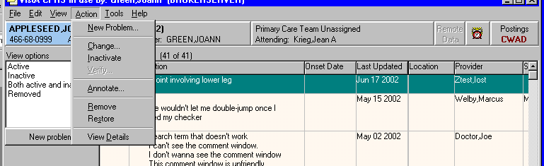

PLPATIENT,
666-00-1111

PLPROVIDER,ONE
PLPROVIDER,ONE

Annotating a Problem

To annotate a problem, use these steps:
1. Click on the problem in the problem list.
2. Select Action | Annotate... or right-click the problem and select Annotate... from the pop-up menu.
3. Enter your annotation in the dialog that appears (up to 60 characters).
4. Click OK.

Changing a Problem

To change a problem on a patient’s problem list, use these steps:
1. Click the Problems tab.
2. Click on the problem in the list box that you want to change.
3. Select Action | Change.
4. Enter the desired changes.
5. Add or remove a comment if desired.

Note: | A comment can be as many as 60 characters (including spaces) in length.

6. Click OK.

Note: | When you view the details of a problem, you will see who changed the problem and when.
:

PLPATIENT,ONE
666-00-1111 APR 30,1944 (56)

PLPROVIDER,ONE
PLPROVIDER,ONE

Inactivating a Problem

To deactivate a problem on a patient’s problem list, use the following steps:
1. Click on a problem in the list box.
2. Select Action | Inactivate.

Removing a Problem

A problem is not removed from the database because things “pointing” to it might be broken if it is removed. A field in the problem record can be “flagged” with an “H” and the problem will be HIDDEN. Any software that runs on the database must look at the field to see if it is hidden or not. The hidden record will not appear on any reports or lists and will appear to the user that it has been removed. Actually it is only removed from sight.
To remove a problem from a patient’s problem list, use these steps:
1. Click on the problem.
2. Select Action | Remove or right-click the problem and click Remove.

Verifying a Problem

To verify a problem on a patient’s problem list, use these steps:
1. Click on the problem in the problem list.
2. Select Action | Verify or right-click the problem and click Verify on the pop up menu.

Helpful Hints & Tips

Helpful Hints

Q: When I want to add a problem that has many different names (more than five) to choose from, is there any way I can scroll back to the top of the list?

A: If you type an up-arrow and the number of the problem (^#), you will go back to the group of five numbers that includes the number you entered.

Example:
Select Action: Next Screen// ad Add New Problem(s)

PROBLEM: diabetes
Searching ...

The following 28 matches were found:

1: Acidosis, Diabetic * (ICD 250.1)
2: Alloxan Diabetes *
3: Diabetes * (ICD 250.0)
4: Diabetes Insipidus * (ICD 253.5)
5: Diabetes Mellitus * (ICD 250.0)

Select 1-5: <Enter>
6: Diabetes mellitus without mention of complication (ICD 250.0)
7: Diabetes Mellitus, Experimental *
8: Diabetes Mellitus, Insulin-Dependent * (ICD 250.01)
9: Diabetes Mellitus, Lipoatrophic *
10: Diabetes Mellitus, Non-Insulin-Dependent * (ICD 250.00)

Select 1-10: ^3
1: Acidosis, Diabetic * (ICD 250.1)
2: Alloxan Diabetes *
3: Diabetes * (ICD 250.0)
4: Diabetes Insipidus * (ICD 253.5)
5: Diabetes Mellitus * (ICD 250.0)

Select 1-5:

Q: Can I add Problem List items to the Health Summary?

A: You can add Problem List components (Active, Inactive, and All) to your Health Summary when you build a Health Summary type. You can also jump between Health Summary and Problem List if you attach the two protocols listed above.

Q: How can I change the length of time before the system times out? Frequently, I have to leave my terminal to take care of a patient or other business; then when I come back, I have to log in and go through all the prompts and such to get back to where I was.

A: Each site sets its time-outs; talk to your ADPAC or IRMS to see what can be done. Security is the main issue in determining time-out times.

Glossary

$ A symbol that can appear beside a problem, indicating that the problem was entered by a clerk and needs to be verified by a physician. For this functionality to exist, a site parameter must be set through the option Edit PL Site Parameters (on the Problem List Mgt Menu).

* A symbol that can appear beside a problem, indicating that the problem has been designated as acute or critical.

Action A functional process a user takes within the Problem List option that affects the end result or, what is actually accomplished by the option.
Examples: Edit a problem, print a problem list, add a comment to a problem.

CPT Current Procedural Terminology, a coding system of medical terms, used for billing purposes.

Clinical Term Names used for problems, diagnoses, procedures, etc.

Clinician A doctor or other health care provider in the medical center who is authorized to enter problems onto a patient’s chart.

DSM-IV Diagnostic and Statistical Manual of Mental Disorders, 4th Ed,.

Encounter Form A paper form (which can be created by a form generator utility) for use with Problem List to print a patient’s problems on, for the clinician to edit and/or add new problems, then used by clerks to enter new problems and/or edit existing problems.

Health Summary A VistA clinical module that allows users to compile summaries of a patient’s health care by combining various components of data drawn from other VistA modules such as Laboratory, Pharmacy, and Radiology.

ICD-9-CM International Classification of Diseases, 9th Rev, Clinical Modification, 1991.

Indian Health Service The Indian Health Service has a computerized
(IHS) system comparable to VistA, called Resource and Patient Management System (RPMS).

Lexicon A terminology utility that uses UMLS terms, the Multiterm Lookup and other utilities to provide clinical terms and concepts, semantic types, special coding, etc.

MCCR Medical Care Cost Recovery, a VistA module that is testing various data entry methods to be used with clinical modules such as Problem List.

MTLU Multi-Term Lookup Utility, a VistA tool that is used by the Lexicon package.

NTRT New Term Rapid Turnaround (NTRT) is the process to distribute standard reference files to VistA and to HealtheVet environments.

PCE Patient Care Encounter, a VistA application.

PL Occasionally this abbreviation for Problem List is used in option or menu names.

Problem The term that the clinician gives to a patient’s complaint or diagnosis.

Progress Note A VistA module, as well as a non-computerized form, for maintaining text about a patient’s condition.

SNOMED Systematic Nomenclature of Medicine, another coding system, used mostly by the Anatomic Pathology module of Laboratory.

Specialty Subset Because many discipline-specific terms are synonyms to other terms, they are not accessible unless you specify the appropriate subset of the Lexicon to choose from. When building problem selection lists, users must choose one of the following specialty subsets: Nursing, Dental, Social Work, Immunology, or General Problem.

UMLS Unified Medical Language System, a combined coding system created by the National Library of Medicine.

VistA Veterans Information System Technology Architecture, the VHA computer program used in VA facilities.

Appendix A: Lexicon/NTRT Tips for the Problems Tab

- Lexicon searches are now based on the SNOMED CT vocabulary, which is more descriptive than ICD-9-CM terms. Therefore you may not see the same terms that you saw in CPRS 28.
- You do not have to update any existing problems to SNOMED CT; the Problems tab will show a blend of existing problems in ICD-9-CM and new problems in SNOMED CT that are mapped to ICD-9-CM.
- Two searches—Initial and Extended: The initial search displays matches from a common list of SNOMED CT terms. If the correct term is not found on the initial list, use the Extend Search button to display a list of matches from a larger set of SNOMED CT and matches from the initial search.
Example from the initial search
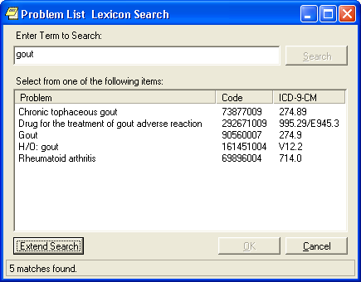

- The extended search displays a list of matches from a larger set of SNOMED CT as well as matches from the initial search. By default, matches from the extended search are mapped to 799.9. When a term is selected that is mapped to a 799.9, a bulletin is automatically generated to the Standards and Terminology Services (STS) team to assign the appropriate ICD-9-CM code(s). The bulletin is titled “Unmapped Problem/Diagnosis NTRT Request”. The Site Coordinator also receives notification, but it is only informational and no work is required. Once mapped, the term will be updated in the Lexicon Utility, resulting in making the term available from the initial search and updating the patient record to the appropriate ICD-9-CM code

Example from the extended search
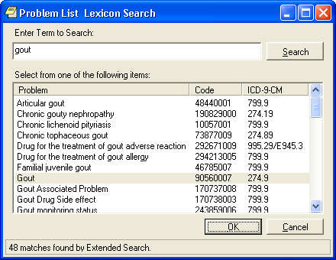

Sample Bulletin for a Problem that Was Selected from the Extended Search

Subj: UNMAPPED PROBLEM/DIAGNOSIS NTRT REQUEST [#196412] 02/14/12@13:01
41 lines
From: GMPL PROBLEM NTRT BULLETIN In 'IN' basket. Page 1 *New*
----------------------------------------------------------------------------
*** Unmapped Problem/Diagnosis NTRT Request ***

Selected SNOMED CT term: Crohn's disease of jejunum
Selected SNOMED CT ID: 91390005
Name of requester: CPRS,Requester
Date/Time of request: 2/14/12@13:01
Service: INFORMATION OFFICE
Location: CHEYENNE VAMC (442)
Search History: crohn

A New Term Rapid Turnaround (NTRT) mail message has been sent to the Standards & Terminology Services (STS) team, and the site coordinator has been copied on the message thread. This is informational only and no work is required by the site coordinator for processing of this request.

This request is generated when a user from the listed facility selects a valid SNOMED CT problem/diagnosis from the extended search option when the initial search does not find a suitable term. The selected problem/diagnosis already has a SNOMED CT ID, but it will be assigned a temporary ICD-9-CM code of 799.9 until a correct ICD-9-CM code is assigned.

After the SNOMED CT problem/diagnosis term is mapped to a valid ICD-9-CM code or set of codes, it will be deployed through the NTRT process and become available for selection by all users who use the search function within the Problem List application. The ICD-9-CM code 799.9 will be automatically updated to the correct ICD-9-CM code after the NTRT deployment and will display in the detail view of the patient's problem on the Problem List tab.

The status and progress of this request may be monitored by accessing the NTRT Web site at http://vista.med.va.gov/ntrt/. Follow the link to Access the NTRT Request Web Site. This mail message is provided to site coordinators as information only, since the Problem List domain steward will be responsible for resolving the unmapped problem/diagnoses requests.

If you have questions, need more information, or are having accessibility problems with this Web site, please contact STS by Exchange email: [VHA OI HDI STS NTRT].

Thank you.

- After the problem has been mapped, STS will distribute the mapping to the Lexicon Utility. As a result, the problem will be selectable from the initial search and the patient record is updated.

Example of the 799.9 Updated in the Patient Record

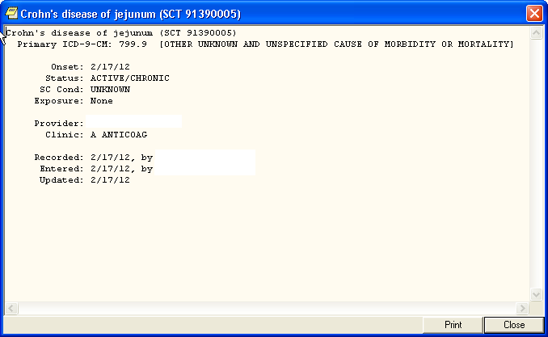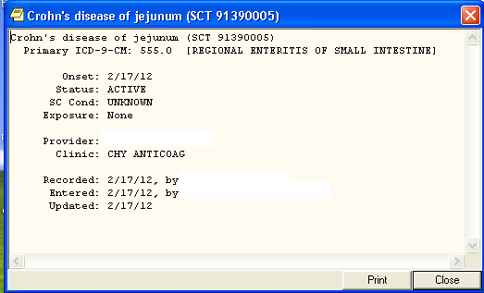

- If there are no matches from the initial search or extended search, a dialog box displays giving the user a choice to submit his/her term to the STS team for consideration to be added to the Core Problem List subset or to return to the search dialog to again search for a closely related term. By clicking on “Apply for New Term” a bulletin is automatically generated as shown below.

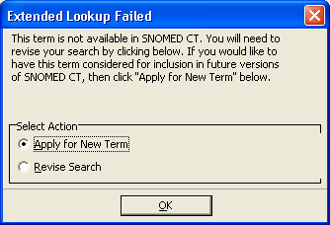

Example of Bulletin for a New Problem/Diagnosis Request

Subj: NEW PROBLEM/DIAGNOSIS TERM REQUEST [#196413] 02/14/12@15:54 33 lines
From: OR PROBLEM NTRT BULLETIN In 'IN' basket. Page 1 *New*
------------------------------------------------------------------------
*** New Problem/Diagnosis Term Request ***

Requested term: acroangiodermatitis of mali
Date/Time of request: 2/14/12@15:54
Name of requester: Ten Cprsprodvider MD
Service: INFORMATION OFFICE
Location: CHEYENNE VAMC(442)

A New Term Rapid Turnaround (NTRT) mail message has been sent to you because a user from your facility has failed to find a suitable term after initiating the search options within the Problem List application
and has chosen to request a new term to be added to the Problem List subset.

Please review the requested term and verify it is understandable, clinically useful, and does not already exist within the Problem List subset. If the term is found appropriate, then submit a NTRT request at the NTRT website, http://vista.med.va.gov/ntrt/. Follow the link to Access the NTRT Request Web Site.

The Problem List domain steward will review each request and respond to you with the outcome of this request. If the term is approved by the Problem List NTRT committee it will be added to the Problem List subset and made available within future searches.

The progress of this request may be monitored by accessing the NTRT website at the NTRT website.

If you have questions, need more information, or are having accessibility problems with this website, please contact STS by Exchange E-Mail: [VHA OI HDI STS NTRT].

Thank-you.

- This document tells how to set up the OR CACS mail group to Receive Problem List Bulletins.


- Submitting New Term Rapid Turnaround Requests (NTRT)
All users must have logon access to submit new term or mapping requests. This is in addition to your VA authentication. If you do not have access, you can use the following link to access a logon request form. Fill in the form and submit it to request access to the site. This request is sent to the VHAT OI HDI STS NTRT mail group that will check for existing access, and if none exists, will create a logon and password and send it to the requester.

Below is the Welcome page where you enter your “Username” and “Password” to logon. Logon names and passwords are case-sensitive.

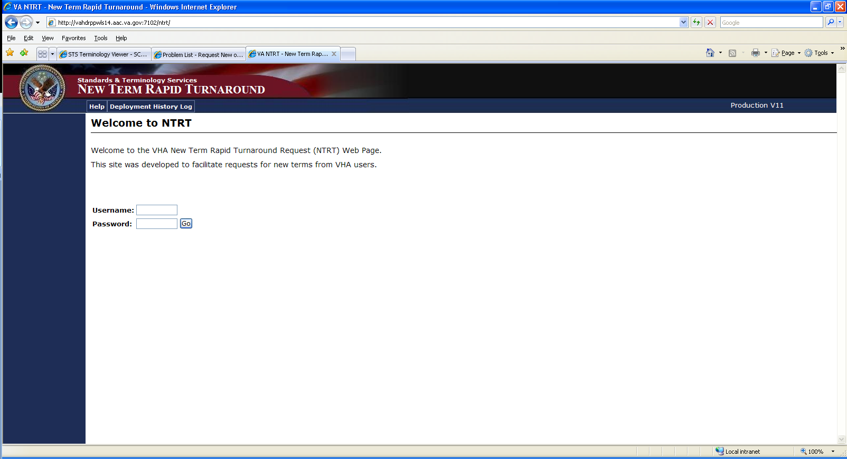

This is the main page for submitting NTRT requests for all standardized domains. Select the Problem List link within the blue side bar to access the Problem List “new term” and “new or mapping change request” forms.

Use the New Problem/Diagnosis Term request bulletin to populate the fields. Here are the definitions of the data fields.
- Requested Term: Enter the text for the new term to add.
- Name of Original Requester: Enter the full name of the person who initiated the request (as opposed to the name of the Site Coordinator, if that administrator is entering the request for another person).
- Service of Original Requester: Enter the care delivery team of the person who initiated the request.
- Location of Original Requester: Enter the site name and number (e.g., 660 Salt Lake City) of the person who initiated the request.
- Comments: Enter the reason for the request or any other information that helps to document the need for the new term.
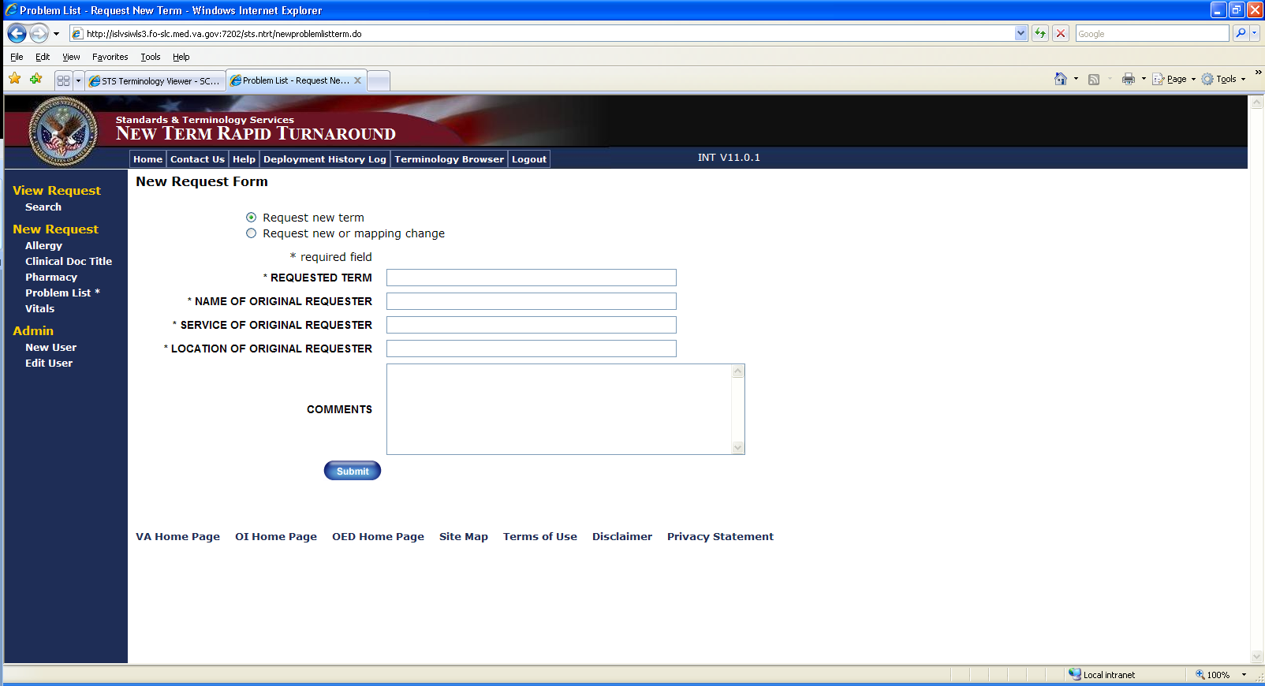

Information to submit a request for a new or mapping change should be obtained from the requester.
- Selected Term: Enter the text of the SNOMED term that is the source of the mapping relationship.
- Selected Identifier: Enter the SNOMED CT ID for the SNOMED concept that is the source of the mapping relationship.
- Name of Original Requester: Enter the full name of the person who initiated the request (as opposed to the name of the Site Coordinator, if that administrator is entering the request for another person).
- Service of Original Requester: Enter the care delivery team of the person who initiated the request.
- Location of Original Requester: Enter the site name and number (e.g., 660 Salt Lake City) of the person who initiated the request.
- Search History: Enter the search terms that were used within the Problem List application in order to determine the need for the new or revised mapping.
- Comments: Enter the reason for the request or any other information that helps to document the need for the new or revised mapping term.
- Suggest New Mapping PDx: Enter the ICD-9 code for the primary diagnosis corresponding to the given SNOMED CT term.
- SDx: Enter up to three ICD-9 codes corresponding to secondary diagnoses associated with the given SNOMED CT term.
- Submit: The submit button sends the request. If any required fields are incomplete, the submission is canceled and an error message prompts the user for the required information.

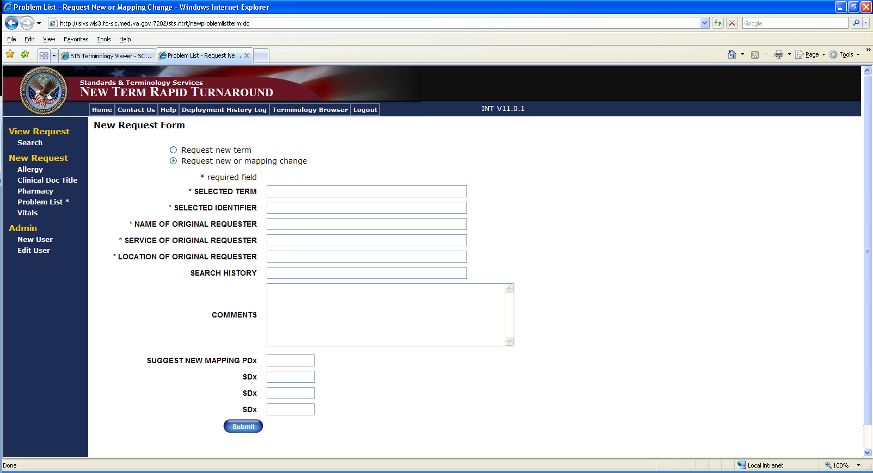

- Setting the new ORQQPL Parameter
This parameter determines whether the user will be shown SNOMED CT and ICD codes when searching for patient problems.
  - Logon to Programmer Mode.
  - Select OPTION NAME: XPAR MENU TOOLS General Parameter Tools
  - Select General Parameter Tools Option: EP Edit Parameter Values
  - Select PARAMETER DEFINITION NAME: ORQQPL SUPPRESS CODES Suppress Codes in Lexicon Problem Search
  - ORQQPL SUPPRESS CODES may be set for the following:

5 User USR [choose from NEW PERSON]
10 Service SRV [choose from SERVICE/SECTION]
15 Division DIV [choose from INSTITUTION]
20 System SYS [VEHU.FO-ALBANY.MED.VA.GOV]

  - Enter selection: 5 User NEW PERSON
  - Select NEW PERSON NAME: <USER>
  - Setting ORQQPL SUPPRESS CODES for User: <USER> Suppress Codes?: NO// ?
This indicates whether code values should be hidden during Problem searches. Suppress Codes?: NO// YES
Setting the parameter value to YES will suppress the code display during lexicon look-ups. If you wish to set it for a given service, division, or system-wide, you can set the value at the corresponding level.
ORQQPL SUPPRESS CODES may be set for the following:
5 User USR [choose from NEW PERSON]
10 Service SRV [choose from SERVICE/SECTION]
15 Division DIV [choose from INSTITUTION]
20 System SYS [VEHU.FO-ALBANY.MED.VA.GOV]

- Setting up CPRS Tools Menu (instructions for this are in the CPRS Technical Manual as well)
- In VistA, go to CPRS Configuration Clinical Coordinator.
- Select GUI Parameters
- GUI Tool Menu Items
- Setup for a User, Location, Service, System, or Division.
- Add New Sequence
- Name=Command: Terminology
- Browser=http://vahdrppwls14.aac.va.gov:7204/sts.browser/index.action
- Open CPRS, Click on Tools in the Menu Bar and View the Terminology Browser. The same steps can be used to add the CPRS Wiki to the Tools Bar.
https://vaww.wiki.webdev.va.gov/index.php?title=CPRS_Tips_and_Tricks

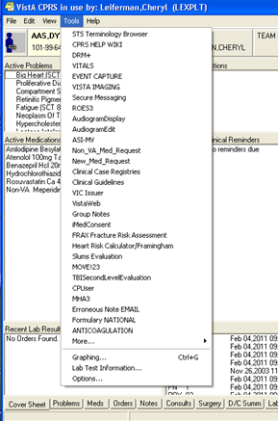

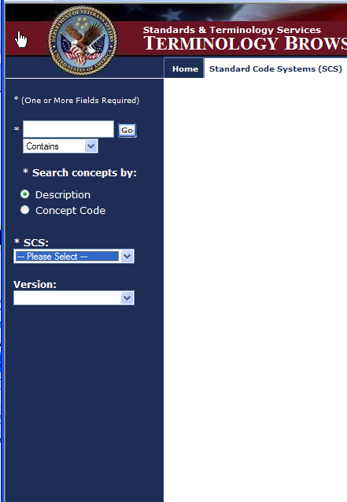

- Setting up Selection List
Below is a quick set up instructions for building a problem Selection List. Refer to Problem List User Manual for other options
Management Menu Options
- Problem List Mgt Menu [GMPL Mgt Menu]
- Create Problem Selection List(s)
- Build Problem Selection List(s)
- Allows you to create a pick list
- Add categories to it
- Add problems to categories
- Assign the list to a user of clinic
- Select LIST NAME: type the name of new selection list that you want to have this list associated
- Type a name for a category you wish to have on your list
- At the “Selection Action”, type AD for Add Problems
- Type the name of a problem for this category
- Accept defaults for display text, code and sequence or enter new values
- Assign List to users to make list available on the Problems Tab

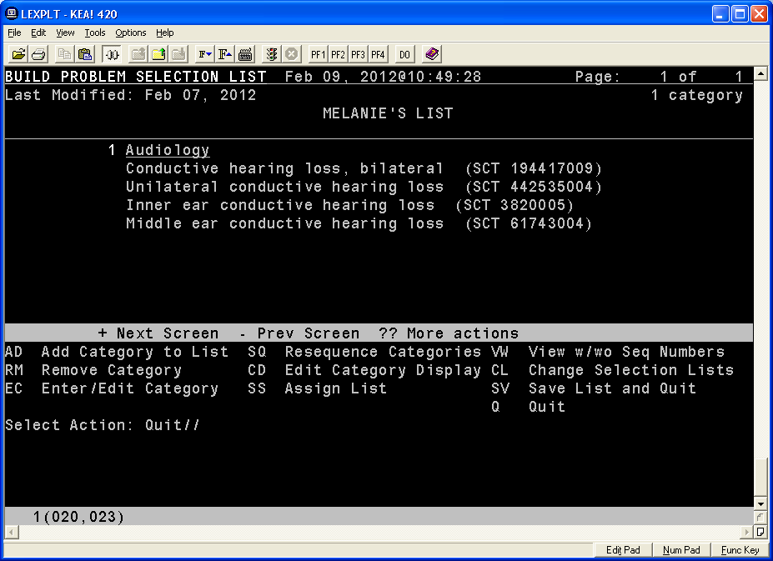

Appendix B: Problem List Standardization Frequently Asked Questions (FAQ)

1. What are the changes being made to Problem List & Encounters for CPRS 29??
The underlying terminology is changing from ICD-9-CM look-up to SNOMED-CT, and the ability to store free-text problem entries is being disabled.

2. What is the terminology of Problem List?
Problems have been described in the past using either terms from ICD-9-CM or from free-text entries that are not part of a terminology. Going forward, new problems will be described using terms from SNOMED-CT, with mappings to ICD-9-CM playing a part in the background.

3. What is ICD-9-CM?
ICD-9-CM is a classification system developed by the World Health Organization to classify diseases, and aggregate diseases according to similar characteristics. To borrow an analogy from a mail room, ICD codes are like bins that correspond to different departments in a building. A very important use of ICD coding is to represent patients’ diseases for varying levels of financial reimbursement.

4. What is SNOMED-CT?
SNOMED-CT is a controlled terminology developed by the College of American Pathologists to uniquely describe diseases & their characteristics, and to organize them into a large hierarchy of all diseases. In the mail room analogy, SNOMED-CT codes are like individual addresses on parcels.

5. How is ICD-9-CM being used going forward in Problem List?
Reimbursement still requires the submission of ICD-9-CM codes, so going forward, each SNOMED-CT code is mapped to (usually one, but occasionally more) ICD-9-CM code. Thus the more clinically-descriptive code is shown for a problem, and the mapped code used for reimbursement and other applications. Both codes are displayable in detail views of CPRS.

6. How do I enter new problems into Problem List?
The procedure going forward is very similar to the way is has been before. You can search for problems by using text (such as exact terms, partial terms, abbreviations, and so on) or in rare events, by using actual codes from the terminology. You will be presented with a list of problem terms taken from the core set of Problem List standardized terms. If you do not see a problem that you want to select, you can go on to do an Extended Search, which will bring back more potential problems for selection. If, none of the extended results represent the problem you have in mind, you can either refine your search, or apply for a new problem. This auto-generates a bulletin to the site coordinator and STS stating that a new term has been requested for consideration. If approved this term will be deployed using the NTRT process and the problem will be added to the core set.

7. What is the core set of Problem List standardized terms?
The first search returns problems that have been selected from SNOMED-CT for their relative clinical applicability. SNOMED-CT is a comprehensive terminology and not all terms are appropriate for documenting problems. Technically speaking, the chosen problem terms are found in SNOMED-CT’s hierarchies almost exclusively as Findings, Events, Disorders, and Situations. This set has furthermore been validated in external collaboration beyond the VA. And this set has been mapped to ICD-9-CM so that encounter and reimbursement information can be completed. Despite the large size of the Standardized Problem List Core Set, there are still many more potential problem terms in SNOMED-CT that have not been selected at this time, which are available from the Extended Search.

8. What is the Extended Search?
This is new functionality in CPRS that allows you to broaden the list of problems from SNOMED-CT as there is need for them. By choosing to perform an Extended Search, all other SNOMED-CT terms in its hierarchy of Findings, Events, Disorders, and Situations are available, based on your search criteria. You will see these in addition to the previous results from the core set of Problem List standardized terms, but none of the new terms from the Extended Search have been mapped. By default they have been assigned as 799.9. Per current functionality, problems mapped to 799.9 still do not pass to encounters, however when a problem is selected through the Extended Search a bulletin is auto-generated to STS and notifies the site coordinators that the unmapped problem will be mapped. This results an update with the appropriate ICD-9-CM code or sets of codes.

9. Is the Extended Search always available?
You will not see the option for an Extended Search if your search terms match a problem exactly. If you still desire an Extended Search, revise your search terms so that no exact match will appear.

10. What if I cannot find a problem that I want even after an Extended Search?
If your term cannot be found following an Extended Search, you will have two options:
- You can revise your search criteria in order to change the search results.
- You can request a new term to be added to the Standardized Problem List Set. Terminologists will then take the request and either look for a suitable SNOMED-CT term, or make a request to SNOMED-CT’s development organization (IHTSDO) for a new term

11. How is the core set of Problem List standardized terms maintained?
There are three key types of updates:
- Every time a new problem is selected from the Extended Search, a request is made for the problem to be added to the core list. Each new problem is updated from the 799.9 to the appropriate ICD-9-CM code by the NTRT process where it adds it to the core set so that it is available for future searches and after it is deployed to the VistA system, the 799.9 is automatically updated to the correct ICD-9-CM code (s). This takes place without the need for any further input from users.
- When new terms are requested following an Extended Search or the user applies for a new term, a request is made for those terms to be found within SNOMED-CT. If there are already suitable terms in SNOMED-CT, then such a problem can be added quickly to the core. If the terms do not exist in SNOMED-CT, then a request for such terms can be forwarded to SNOMED-CT’s curators at IHTSDO. New core terms requested in this way are not automatically added to the patient’s chart of the time of the request, but will be available for future charting.
- Standards Development Organizations make updates to their terminologies on a regular basis, and these changes are transmitted to the Problem List core terms automatically on a periodic basis. Such updates require no input from users.

12. What is happening to free-text problem entry?
Free-text problem entry as you have known it is being discontinued. Unless you choose a new problem from the Extended Search in Encounters, all new problems must be found first in SNOMED-CT. There are some factors, however, that mitigate against the loss of free-text problem entry:
- SNOMED-CT contains tens of thousands of clinically-descriptive terms, far more than what you had available with just ICD-9-CM. And rather than having to choose terms that group diseases as before with ICD-9-CM, you will be able to choose terms that better specifically describe problems at hand.
- Commenting on new problems is still available, so you can still make annotations that reflect real clinical-thinking rather than being stuck simply with a near-description.
- Finally, free-text problem entry has never been available for encounters or reimbursement information because a highly non-specific ICD-9-CM code always had to be used for these that essentially conveyed no information. While this may have been highly convenient for documentation, it did very little for broader use of the medical record.

13. Will all problems now be terms from SNOMED-CT?
There are two significant cases where problems will not be from SNOMED-CT:
- Any problems that are already present prior to CPRS v29 will still be rendered primarily as being from ICD-9-CM, or as free-text as the case may have been. Existing problems will not be affected in any way with CPRS v29.
- It will still be possible to enter problems solely by ICD-9-CM code from the Extended Search in the Encounters application, in order that workflow not be disrupted there when the primary concern is the assignment of an ICD-9-CM code.

14. Do I need to update my existing problems to SNOMED-CT?
No, there is no need to update any existing problem to SNOMED-CT.

15. What if a problem is not described as I am used to seeing?
You may notice in searching for or selecting a new problem that some ways of describing it do not appear. This has to do with the broad expressivity of SNOMED-CT and the limitations of CPRS and peoples’ willingness to wade through very long lists of terms. Each SNOMED-CT concept has a single Preferred Term, and this is the term that is used to represent problems in Problem List. Almost all SNOMED-CT concepts also have many other descriptions as synonyms, but due to the voluminous (and often non-specific) nature of so many terms, while these are used in searching, they are kept in the background. So while on one hand they are not available for describing the problems, the search results are scalable and efficient by not clogging the system, or users, with excessive terms.

16. Is the process for entering problems the same between the Problem List application and the Encounters application?
The initial search functionality is exactly the same, but there is a difference when it comes to the Extended Search. One way to think of the Extended Search is as a deeper dive into the terminology at hand. In the Problem List application, that terminology is SNOMED-CT, as has been described earlier. Since the Encounter application seeks to deliver an ICD-9-CM code for reimbursement, you could think of ICD-9-CM as the deeper terminology there. Therefore an Extended Search from the Encounter application will not search SNOMED-CT, but ICD-9-CM instead, and any problems selected there will not have a SNOMED-CT term associated with it. There is furthermore no option beyond the Extended Search in the Encounter application, as only the available ICD-9-CM codes can be chosen which satisfies the check-out process

17. How can I document a patient’s historical findings like past medical and surgical history, or family history, or social history?
SNOMED-CT includes many terms that represent these kinds of findings, from a fairly non-specific point of view, down to terms that more fully describe these historical elements.
- The broadest level of these categories are terms such as:
  - History of surgery
  - Social and personal history finding
  - Finding of history relating to military service
  - Past history of procedure
- There are more fully-specified terms such as:
  - Family history of stroke
  - Family history: allergy
  - History of endocarditis
If you cannot find an exact match for a particular finding, you can use one of the less specific terms and annotate the condition using Comments.

Index

A
Add New Problems, 59, 69
Assign ICD Diagnoses to Problem List, 14, 79
Assign Selection Lists to Users, 36

B
Build Problem Selection List(s), 28

C
Clinical Lexicon, 1, 8, 95
Comment on a Problem, 74
Conventions used in this manual, 10
Copy Selection List from IB Encounter Form, 33
Create Problem Selection Lists, 24

D
Data capture, 2
Delete Problem Selection List, 36
Detailed Display, 75

E
Edit a Problem, 77
Edit PL Site Parameters, 23
Electronic Signature, 12
Encounter Form, 10, 24, 33, 95

F
Features in Problem List, 1

G
Glossary, 95

H
Health Record number, 82
Health Summary, 95
Helpful Hints, 92
How to Use this Manual, 5

I
IB Encounter Form, 10, 24. 93, 95
ICD-9-CM, 94
Implementation of Problem List, 10
Inactivate Problems, 79
Integrated Billing Encounter Form, 10, 24, 33
Integrating clinical data, 82
Introduction, 1

L
Lexicon, 1, 10, 95
Links to other packages, 10
List Patients with Problem List data, 37
List Manager Conventions, 6

M
MCCR, 95
MTLU, 95
Multi-Term Lookup Utility, 95

N
National Library of Medicine, 96

O
Orientation, 5
Overview, 1

P
Package Management, 10
Package Operation, 48
Patient Care Encounter (PCE), 11, 95
PCE, 11, 95
Preferred Problem Selection List, 43
Print Problem List, 80
Problem, 95
Problem List Data Entry, 53
Problem List Preferred View, 41
Problem List User Actions, 66, 89
Problem Look-up Defaults, 42
Progress Note, 96

R
Related Manuals, 1
Remove Problems, 83
Remove Selection List from User(s), 35
Replace Removed Problems on Patient’s List, 39
Search for Patients having selected Problem, 38
Security Keys, 10
Select New Patient, 84
Select View of List, 59
Show All Problems, 86
SNOMED, 97

T
Terminology, 1, 10, 94

U
UMLS, 96
Unified Medical Language System, 96
User Preferences, 41

V
Verify Problems, 87

